Incremental Load in QlikView – 1
In QlikView,incremental load is used when large trasactional tables are involved. Incremental load is a mechanism by which a data is appended or updated in large transactional tables.Incremental load require the use of QVD files for data storage.
Why use incremental load
In many business environments, there will be many large transaction tables. These tables may receive 1000′s or millions of rows of data daily or monthly. Since the data is huge and it may be sensitive also from the history standpoint, you many not want to delete the existing records, instead you will load only if the data is new. In such scenerios incremental load is used.

3 Options are available for Incremental Load
1. Insert Only
2. Insert and Update
3. Insert, Update and Delete
In this Part I ,i will show you Insert Only option
To show the concept of Incremental load, i will use and load table Incre_Table1. Before starting with incremental load, you have to do a initial load, which is just storing all the data present in the table to QVD.
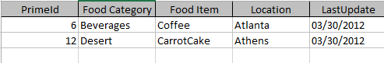

Insert Only
Insert only is the process which just takes new data from the source and adds it to the existing QVD
Steps :
1. Load all the data from a db table and store it into QVD.This is referred as initial load
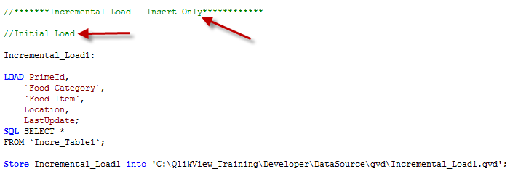
After the initial load, i have added a row in my table so that we can load this updated row. With new row the table will look like the following, notice the LastUpdate date in the last row.
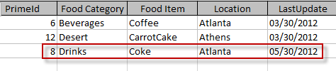

2. Load all New data from the db. There can be many ways to identify New data. One way is to have a LastUpdate date in table and while loading the table check for the last update date.
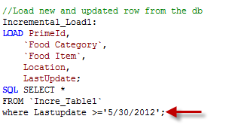3. Concatenate this data with the Load of all the data from the QVD file and store the entire table into the QVD. This will overwrite the existing QVD.
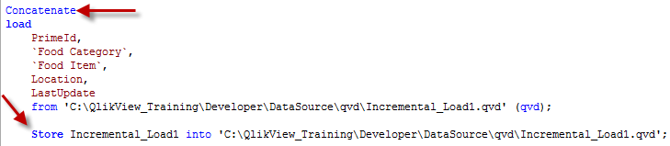

This completes Incremental Load with Insert Only option. In the next blog i will show you how to perform incremental load with Insert and Update And with Insert,Update and delete option.

Tags: Incremental load, Incremental load in QlikView, Learn QlikView, QlikView Tutorial

Incremental Load in QlikView –2
In this session, we will see how to do Incremental Load with

- > Insert and Update

- > Insert, Update and delete

Insert and Update
Incremental Load with Insert and Update is similar to “Insert Only” (see my earlier blog Incremental Load in QlikView – Part1)
In this type of Incremental Load you will take new rows from the database and add/append to the existing QVD.
In our previous excercise, we have loaded, the following rows/table in QlikView QVD
For this example, i will add 2 new rows into my existing database table
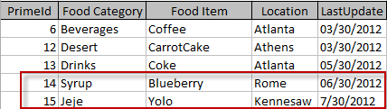

Now our objective is to load only 2 new rows and not to overwrite the entire table
1. We will start with the inital load
2. Incremental load i.e. load new rows based on the LastUpdate date
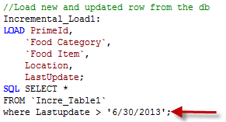
3. Concatenate. Here you will check for PrimaryKey and load only those rows where PrimaryKey is new.This will ensure that only new rows are added and existing rows are not overwritten
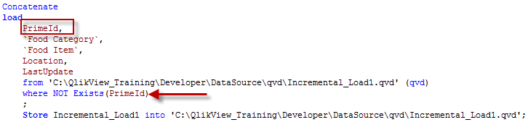

Insert, Update and delete
This option is similar to Insert and Update with only exception that you need to exclude/delete records that have been deleted from the source system.
To explain my point, i have deleted a row and added a new row in my database table. I have deleted the row where PrimeId = 6. Now my database table looks like
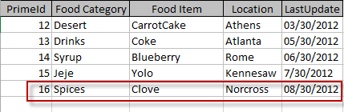

Now using Insert,Update and delete , you should be able to load the new rows and exclude the ones which are deleted in the source system and store the result into qvd.
Follow the same steps as above with Initial load,Incremental load,concatenate and then use Inner join script to exclude records that are deleted from the source system.
After executing this load, you will see that new rows are added to your qvd and the row which was excluded from the db is deleted from your qvd.
If you select from the Qvd and create a Table box, it will look like the following, your qvd deleted the record for PrimeId = 6 and added a new record where PrimeId = 16
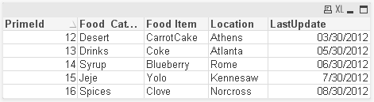
Incremental loads are very useful when you have to load large transactional tables frequently and maintain the data integrity.

