Sorting in Pivot Tables

The “problem” with the sorting in Pivot Tables in Qlikview is that unlike straight tables that is very easy and straightforward to apply the sorting for any column you want
in Pivot Tables, in most cases you will use the expression field. Please look below:
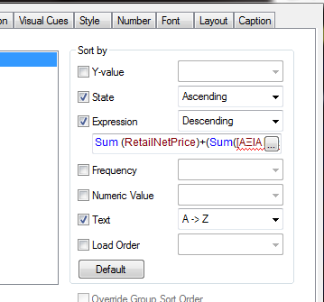
Using this technique you will be very easy control the sorting (ascending or descending) of the table based on the formula you enter at the expression.
In most cases the user should be use this kind of sorting trick. It is not difficult and at the same time is very effective. You can write any expression you want.
T.P.S.

