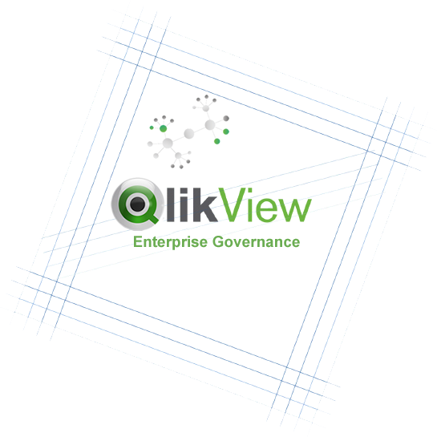
QlikView
Center of Excellence
Practical Advice for Governing Agile User Driven BI

Version 1.2
March 2014

Executive Summary
For those of us who have worked in Corporate IT for a while, we know that even in the most complex of technology implementations, the technology is usually the easiest part. In order to ensure success, it is often the people and process questions which encompass a deployment that make the difference between successful adoption and delivery on the promised ROI.
QlikView empowers IT to deliver exceptional business value to their business partners in an agile manner while still maintaining governance and control over the core IT values. Establishing a QlikView Center of Excellence (QCoE) ensures that the people and processes that will govern your Enterprise QlikView deployment are addressed in a way that maximizes your investment in QlikView and enhances IT-Business partnership.
At a high-level, this paper attempts to offer advice on the question: “How do we create a flexible model for business intelligence delivery that provides discipline at the core while giving the business the agility that they need to drive the business forward in today’s information economy?”
To do so, this document outlines a broad range of items that we believe are necessary for you to consider when establishing (or improving) your QlikVIew Center of Excellence (QVCoE). And, to kick start your efforts, we have created an online QlikView Enterprise Governance Community Group where we (and hopefully you) will share lessons learned, templates, and examples.
What is most important to understand is that there is no one right answer. Depending on corporate culture, resource constraints, or other factors, each firm will vary in the final details of their implementation. However, the core mission and charter of every QlikView Center of Excellence will include at least a few objectives in common:

- Strengthen IT-Business Partnership
- Engage the Entire Spectrum of Users
- Drive Business Community Efficacy
- Maintain Data Agility
- Foster, Capture, & Share Innovation
- Increase Enterprise Analytical Aptitude

Contents
Executive Summary 2
Overview 7
What is a QlikView Center of Excellence (QVCoE)? 9
Business and IT collaboration 9
What are the benefits of a QlikView Center of Excellence? 11
Why Establish a QlikView Center of Excellence (QVCoE)? 13
When should you establish a QlikView Center of Excellence? 14
What does a Center of Excellence do? 15
Amplify BI Impact 16
Balancing User-Driven BI with Appropriate IT Support 17
What if I need additional guidance? 18
QlikView Center of Excellence Community Group 18
QlikView Consulting Service CoE Assessment 18
Partners 19
QlikView Center of Excellence Considerations 21
Overview 23
A. Charter 25
Create Vision 27
Executive Sponsorship 28
Delivery Patterns 29
Project Intake Process 32
B. People 33
Roles & Responsibilities 35
Responsibilities Matrix 41
Team Structure 43
Collaboration Process 45
C. Technology Process 47
Delivery Process 49
Application Certification 49
Communication Plan 50
Data Model Training 51
Application Training 51
Best Practices 53
Governance Model 54
Onboarding Process 55
D. Service Management 57
KPIs & Metrics 59
Support Model 60
Service Level Agreements 61
Service Chargeback 62
Common associated service costs 62
Appendix 63
Role Descriptions 65
QlikView Developer 66
QlikView Designer 67
QlikView Administrator 68
QlikView Architect 69
Version Log 71

Overview

What is a QlikView Center of Excellence (QVCoE)?
The QlikView Center of Excellence (QVCoE) is a term that is used to describe the people and processes that will govern your Enterprise QlikView deployment. The general mission of the QlikView Center of Excellence is to enable IT and the business users to work together to solve business problems and to share knowledge and analytics across individuals, groups, and the organization.

CENTER OF EXCELLENCE
refers to a team, a shared facility or an entity that provides leadership, evangelization, best practices, research, support and/or training for a focus area.
In some organizations, especially those with larger deployments, the QVCoE will be managed by a distinct group of individuals whose soul responsibilities are those relating to QlikView. However, in other organizations with smaller deployments or smaller numbers of people available to staff the team, the QVCoE may simply be a function of a larger more diversely focused BI team or BI Competency Center (BICC).
Either way, we believe that the key success factor for QlikView is a strong focus on business enablement rather than simply on service delivery. The most successful deployments of QlikView are those which remain true to the user-driven nature of business discovery and those which are able to deliver QlikView in a flexible manner supporting the business user’s needs anywhere along the technical spectrum.

Business and IT collaboration
We fundamentally believe that BI or analytics is not an ‘IT problem’ or ‘business problem’ but rather a shared opportunity that can only deliver its true potential when IT and the business work collaboratively. The main way that QlikView differs from other BI CoEs and BI technologies in general is the inclusion of the business and IT in various hybrid roles. In these roles, both IT professionals and business users blur the traditional lines between organizations. Business users not only contribute to requirements and testing but in some cases get involved in design and development as well.
Rather than viewing IT as the sole provider of BI services, we instead see IT as an enabler of the business user community’s ability to drive analytics themselves. Rather than needing to do everything within IT, think of the business users as an amplifier to your ability to drive analytics within your organization. This only makes sense because analytics is most powerful when placed in the hands of the very people who are most intimately involved with the business problems in need of data driven decision support: the business users themselves.

What are the benefits of a QlikView Center of Excellence?
Among other benefits, a QlikView Center of Excellence ensures implementation consistency, governance, scalability as well as reduction of deployment time of each QlikView project. Not surprisingly, many of these are similar to the benefits that you would see in any other Center of Excellence. This is because the primary role of any CoE is not to purely manage the technology but rather to focus on the people and process concerns to ensure success.

Increase Supportability
Document and Share Best Practices
Foster Good Design
Provide Security & Compliance Oversight
Reliable Scalability & Performance
Ensure Repeatability
Ensure Consistency
Maintain Quality
Increase Trust in Data Output
Ensure Agile Solution Delivery
Propel IT-Business Partnership
Foster, Capture, & Share Innovation
Increase Analytics Adoption
Accelerate Decision Making
Optimize Resources & Reduce Costs

Of course, different benefits will have different levels of appeal to different organizations. But in general, we find that the following three key benefits resonate with most, if not all, of our customers.
Consistency | With centralized resources and processes, it naturally follows that it will be much easier to ensure consistency throughout your QlikView implementation. This includes both design and development standards leading to more reuse, easier maintenance, and better scalability and higher user adoption/acceptance.
Agility | QlikView already offers a rapid time to value. However, the ability to reuse components and leverage deepening skills will drive the ability to deliver faster. Business involvement and the possibility to establish business prototyping as part of the CoE also drives an agile way of working.
Cost | Both of the prior two benefits ultimately lead to lower costs. Maintaining a consistent agile development environment results in the ability to utilize fewer resources. However, ensuring that you have quality and well-performing applications ensures savings on software and hardware as well.

Why Establish a QlikView Center of Excellence (QVCoE)?
As mentioned above, even in the most complex of technology implementations, the technology is often the easy part. People and process issues tend to make the real difference between a technology solution’s success or failure. This is no less true in the area of Business Intelligence.
According to Gartner both CIOs and CFOs list Business Intelligence and Analytics as their top priority. Despite this focus, organizations have had a difficult time deploying BI successfully. In fact, according to the BI Scorecard, BI adoption rates have essentially hovered around the 25% mark since they started surveying companies back in 2005.
Clearly something about the traditional model for Business Intelligence service delivery isn’t working. But our inability to deliver on the promise of BI hasn’t eliminated the business’s need to understand their data. In frustration or even desperation, the business community has often forged their own path forward without IT either in the form of Excel or even non-IT sanctioned implementations of QlikView.
With QlikView “I am finally a sales analyst, not a data analyst”
Although the business users may be content, this type of scattershot implementation can be fraught with security and regulatory hazards. At a minimum, it doesn’t take advantage of the economies of scale, efficiency, and technical expertise that are the hallmarks of a well-managed centralized IT organization.
Or you may be one of the forward thinking firms who have chosen to head off the revolt before it starts by proactively delivering a user-driven model for business intelligence to your business users with QlikVIew.
In any case, QlikView provides a powerful platform on which to deliver agile user-driven BI while taking advantage of all of your data – across data silos both big and small.

When should you establish a QlikView Center of Excellence?
Getting started with QlikView is easy. A typical scenario begins with one person downloading and utilizing the free QlikView desktop developer for their own purposes. But inevitably, there will be a desire to share their QlikView solutions with more and more users which typically leads to a request for IT to support a QlikView server. As time goes on, QlikView usage tends to not only grow within that one department but will also eventually span multiple departments driving IT to grow their capabilities as well.
The other common scenario is a strategic decision on the part of IT. Frustrated with a never ending backlog of BI requests, declining resources, and a deep desire to serve their user community, IT departments will proactively choose to deliver QlikView’s user driven BI platform as a service. Either way, it is at the point that QlikView begins to spread between departments that there is a significant opportunity for sharing of resources and assets. This is the point at which firms should consider adopting a QVCoE. Of course, as additional departments begin to utilize QlikView, the benefits of a QVCoE only become more and more apparent.
Implementation of a QVCoE

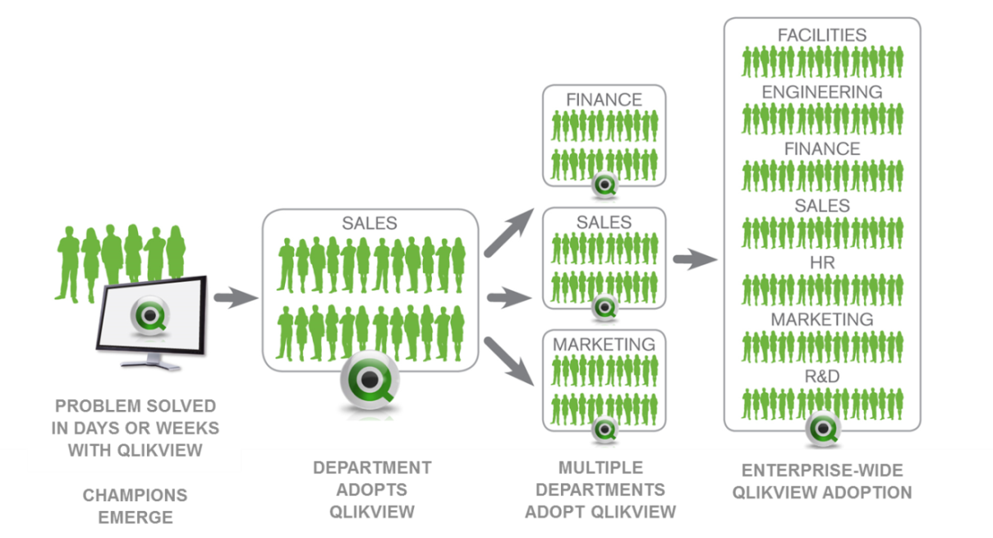

What does a Center of Excellence do?
The types of services that a QlikView Center of Excellence performs are very much in line with what you might expect in any other Center of Excellence. However, one key differentiation is the emphasis placed on inclusion of the business. In fact, as we will see later, many of the roles traditionally defined as “IT” can - and often will - be handled directly within the line of business rather than in IT.
The following is a high level view into the types of activities that will take place within the mission of the QVCoE. It is not intended to be an exhaustive list but rather a framework to begin thinking about the roles and skill sets that we will discuss further along.

Data Architecture
Application Architecture
Collaborative Development
Security
Application Development
Program Management
Prototyping & Agile Delivery
Green-lighting of new large projects
Resources Planning
Budgeting
Technical Architecture
Performance Management
License Management
Infrastructure Services

Center of Excellence
Governance
Monitoring & Oversight
Knowledge Capture & Exchange
Relationship Management
Training & Adoption

With all of these components, it is important to stress that the most successful deployments of QlikView take hold when there is both business and IT partnership every step along the way. Remember, BI and analytics is not a business problem or an IT problem but rather a shared opportunity.

Amplify BI Impact
Again, one of the key aspects of a QlikView Center of Excellence is the idea of leverage. By providing a thoughtful set of key centralized services, IT can amplify the BI capability of the entire enterprise. To do this, IT does not ask ‘what questions do my business users want to answer?’ instead, they ask, ‘what types of questions does my business community want to explore?’
IT focuses on key areas of data governance, service performance, and compliance while empowering the business to focus on the business questions of the day. By doing so, IT magnifies the entire enterprise’s ability to deliver BI capability into the hands of more and more users.
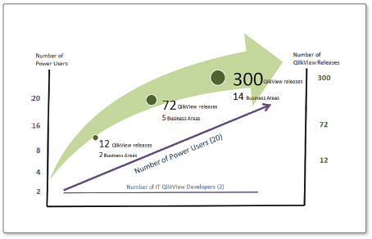

Balancing User-Driven BI with Appropriate IT Support
User-driven BI does not mean that the IT organization just tosses a tool over the wall to the business. Rather, IT focuses on business user enablement while still taking on traditional IT responsibilities when needed as well. Here we see a balance of user-driven activities alongside those still managed and supported by IT.

IT provides greater assistance for establishing the framework and supporting the implementation of large projects. However, they play more of a supporting role in general business discovery and other self service activities.

Highly
Provisioned
Enable
These
Self
Service
Business Discovery Sandbox
QlikView Projects
Data Discovery / Scoping
QlikView
Data
While you
work on
these

Non
Provisioned
Highly
Developed
Undeveloped
Requirements

What if I need additional guidance?
Hopefully, you will find that this paper represents a great kick-start to your efforts. Combined with institutional knowledge that you may have from other similar efforts, you may feel like you have everything you need to get underway. However, for some firms, you may be in unchartered territory and might be looking for additional help. Or, maybe you would simply like to assess your current QlikView Center of Excellence in an effort to continuously improve your service offering. Either way, there are several resources that you will find helpful including:
- QlikView Enterprise Governance Community Group
- QlikView Consulting Services
- QlikView Partners

QlikView Center of Excellence Community Group
QlikView’s online community is a great way to connect with other QlikView customers with similar interests and concerns. On QlikView Community, you will find a group established specifically for Enterprise Customers who are interested in the topic of governance and CoE:

QlikView Enterprise Governance (http://community.qlikview.com/groups/qlikview-enterprise-governance).

The primary focus of this group is to answer the people & process questions associated with Enterprise level deployments of QlikView. Using this document as a starting point, we will use this forum to discuss related topics as well as to share templates and examples.

QlikView Consulting Service CoE Assessment
One of the many services provided by QlikView Consulting Services is the CoE Assessment. The COE (Center of Excellence) Assessment provides a clear strategy for a COE or shared service platform to increase adoption and readiness for QlikView at a pace and style that fits with your organization’s culture. This alignment enables QlikView applications to be built, deployed, and governed efficiently, with higher quality, more timely delivery, and greater business value.

During the engagement, QlikView Consulting Services will review the key areas of CoE readiness and recommend ways your organization can enable rapid adoption of QlikView for application development, self-service business discovery, and production deployments across business and IT functions. You can use the resulting assessment to communicate structure and governance of QlikView applications, resources, and environments to senior leadership and to key stakeholders across your organization.

For more information about the COE Assessment or other QlikView Consulting Services offerings, please contact your account manager or a QlikTech office close to you.

Partners
QlikTech partners with over 1500 local, national, and international business consulting and system integration firms to deliver the benefits of QlikView to their clients - businesses just like yours. Many of these firms offer consulting services including those needed to establish or strengthen your QlikView Center of Excellence.

To find a partner in your region, please visit http://www.qlikview.com/us/partners/find-a-partner

QlikView Center of Excellence Considerations

Overview
The remainder of this document is dedicated to providing a high level overview of the various areas that we believe you will need to consider when establishing your QlikView Center of Excellence. These can be grouped broadly into the following 4 categories.
- Charter
Here you will set the direction and scope of your QlikView deployment alongside your Executive Sponsor.
- People
These items are used to outline the resources that you will need as well as to set general expectations for how everyone will work together.
- Technology Process
Items in this section are focused on the technology process questions around your QlikView deployment including the what and how of application delivery.
- Service Management
Service Management is focused on items such as how to measure success and how to secure ongoing funding.
You will find a number of templates and examples to get you started both here in this document as well as within the QlikView Enterprise Governance Community group. One common method of getting started is to hold a one-to-two day workshop to work through an initial outline for each item and then to refine them over the following weeks or months.

However you choose to go about it, with the exception of the first two items which should be completed first, the following list may be tackled in any order.
- Charter
  - Vision Establish a guide post
  - Executive Sponsorship Eliminate roadblocks to change
  - Delivery Patterns Determine what will be delivered with QlikView
  - Project Intake Outline how new work will be accepted
- People
  - QlikView Roles Determine what resources are needed
  - Team Structure Determine who will reside in IT or the business
  - Collaboration Process Establish guidelines on how we work together
  - Onboarding Process Establish methods for training new people
- Technology Process
  - Best Practices Document development and UI guidelines
  - Delivery Process Develop process for application implementation
  - Governance Model Ensure ongoing environment stability and consistency
- Service Management
  - Metrics & KPIs Quantitatively define success
  - Support Model Determine who is responsible when help is needed
  - Service Level Agreements Establish committed SLAs
  - Chargeback Model Establish mechanism for cost recovery

A.
Charter

Create Vision
The vision for your QlikView Center of Excellence allows you to articulate the value that you are striving to achieve with your QlikView deployment. Your vision document, which may take the form of a text document and/or a presentation, serves as an important guide post when making trade-offs during efforts later along your deployment path.
This document should be completed at the beginning of your efforts in order to set a clear direction. However, you will also want to revisit the Vision as the final step in your plan in order to take into account any changes that may have resulted from your efforts.
Consider the phrase “think big but start small”. Your vision lays out a plan for what your QVCoE will strive to accomplish over time. However, the reality may be that this plan will need to be phased in with the first phase focusing a small targeted high value business problem. Your vision should describe both the long term goals as well as the shorter term focus.
To start, you should attempt to explain the following:
- Describe the business imperative you are trying to solve
- Explain why you are looking to form a QlikView Center of Excellence
- Outline the resources (existing or new) that you will need at a high level
- Explain who you expect will need to be involved
- Outline the plan for establishing the Center of Excellence including a time table
- Describe how you will measure success during the implementation phase

Executive Sponsorship
Regardless of how formal or informal you expect your Center of Excellence to be, Executive Sponsorship is key. In reality, this is true for any analytics effort. If senior leaders do not support the need for data-driven-decision making then adoption levels will necessarily follow. In addition, QlikView deployments challenge the traditional model of Business Intelligence service delivery.
Successful delivery will involve new ways of thinking about how the business and IT work together including the blurring of some of the traditional us-them thinking. Having an Executive Sponsor can go a long way in ensuring that you are able to deal with any organizational or budgetary issues that might arise.
It is also critical to recognize that QlikView is one component of what is likely to be a complex data ecosystem. The Executive Sponsor will need to understand – at least at a high level – enough of ecosystem to assist with roadblocks not only within the QlikView CoE but also in other related areas. Remember, it is estimated that at least 70% of all data related efforts revolve around ensure that the data is ‘right’. One of the powerful aspects of a QlikView deployment is that it can bring to light some important data issues that will need address and you sponsor may need to step in to get the right people involved.
Ensure that your Executive Sponsor:
- Is in a position to assist you with anticipated road blocks.
- Is aligned with your Vision for the QlikView CoE.
- Is educated on the value of the QlikView platform.

Delivery Patterns
The purpose of defining the delivery patterns for QlikView is to determine which BI capabilities will be delivered using QlikView and just as importantly, which will not. QlikView is a robust platform that can meet just about any Business Intelligence reporting need. However, most companies have a preexisting portfolio of tools and it is important to clearly identify how each will be used.
Outline Tool Usage
The first step is to draft an outline of how each tool will be utilized in your environment. Create a simple matrix with the various BI tools in your environment across the top and the following row headings:
- Capabilities – what types of activities do you expect to be fulfilled with this tool
- Data sources – what types of data sources are available to each tool
- Users – which users are expected to utilize each tool
- Project Timeline – what is the anticipated timeline for completion for a typical project

Fill the matrix in based on your expectation of where you would like to get to.

BI AREAS | QLIKVIEW | COGNOS | SAS | EXCEL
Capabilities | - Visualization  - Data Discovery  - Interactive Dashboards | - Corporate Reporting  - Dashboards  - Ad-Hoc Query | - Statistics  - Predictive Analytics  - Data Mining | - Ad-Hoc Views
Data Sources | - ERP  - Data Warehouse  - Excel/CSV/Access  - Any as needed | - Data Warehouse | - As needed | - As needed
Users | - Knowledge Workers  - Executives, Managers, Business Analysts | - Consumers and Recipients | - Statisticians | - Business Analysts
Project Timeline | - 4-12 Weeks | - 6-12 Months | - Months | - Days
Developers | - Business Analysts  - Power Users | - IT Report Authors | - Statisticians | - Analysts and Consumers
This simplified matrix can serve as your guidepost until you are able to complete the following steps which will provide more detailed guidance on how each of the tools will be utilized in your environment.

BI Delivery Patterns
The next step is to identify the BI delivery patterns within your organization. You will find an example of this on the next page.
Dashboards
1 | Departmental Dashboards | Interactive dashboards built upon well-provisioned, conformed data sources.
2 | Cross-DB Dashboards | Interactive dashboards sourced from disparate data sources that may or may not be conformed and well-provisioned.
Reporting
3 | Departmental Reporting | Static and/or parameterized reports built for internal user audiences - less need for pixel-perfect rendering and complex presentation
4 | Corporate Reporting | Static and/or parameterized reports built for external and executive audiences (including regulatory reports) - pixel perfect and/or complex presentation
5 | Ad-Hoc Reporting | Query or batch-based data delivery from one-off or custom requests - delivery in data set, spreadsheet or custom report form
Discovery, Analysis, and Visualization
6 | Business Discovery | Visual exploration of disparate data by business users for the purposes of discovery, what-ifs, scenarios, trending and correlations that are not yet known
7 | Visualization | Interactive exploration of data by data practitioners, for the purposes of Pre-ETL, Correlation Analysis, Data Profiling, Data Quality, etc…
8 | Prototyping | Rapid models and interface prototypes to prove out business value and technological fit
Advanced Analytics
9 | Statistical Analytics | Statistical analysis, trending and reporting - beyond basic statistical analysis. These are statistical/scientific analysis based on advanced modeling.
10 | Predictive Analytics | Predictive analysis, projections, scenarios and models for future events based on historical data and controllable variables - beyond projections, what-ifs.
Other
11 | Budgeting & Forecasting | Budgeting analysis and entries with reporting. Financial forecasting, with write-back to forecast system.

Delivery Pattern Matrix
The next step is to complete the Delivery Pattern Matrix. In this example, Key BI Delivery Patterns are identified across one axis and data delivery methods are identified along the second. For each combination, determine which platform will be used to support the need within your firm.
Different organizations will want to organize their matrix along different dimensions The goal is the same: to foster a discussion regarding where QlikView should and shouldn’t be utilized to solve a business problem. Another example of how this might be organized is along ‘type of data’ and ‘role of the user’.
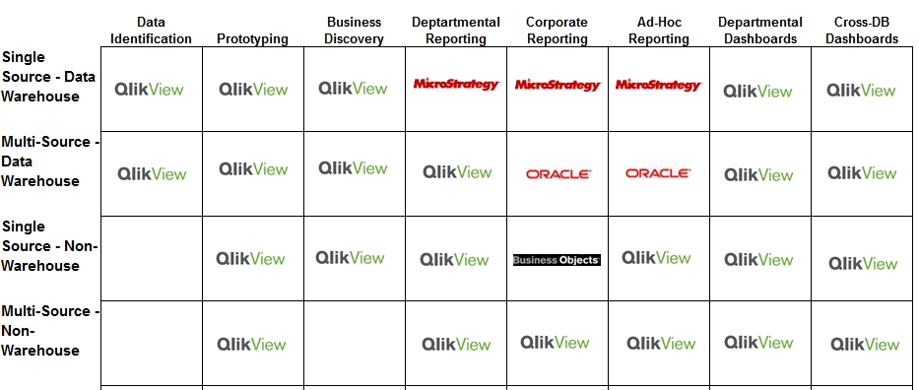
Once you have your matrix, the next step is to identify which solution platform will be used for each potential type of data project using the following considerations.
- Data Sources – Where is the Data coming from and how easy/hard is it to access?
- Capabilities – Are there common capabilities that the Business is requesting?
- Type of Users / Consumers – What types of users are using and requesting BI?
- Time to Market – What’s the timeline to deliver the project?
- Report Developers – Who will be responsible (Business or IT) for development?
- Governance – How important is governance for these applications?
It is important to note the matrix does not reflect a need to go back and move all existing reporting over to QlikView. Although that is possible, a more likely scenario is that the matrix represents your go-forward view of how to satisfy new requests or significant changes.
Ultimately, you may even choose to create multiple versions of the delivery matrix. For example, you might create a version for the current state and for the future state. In more complex environments, you may even find it helpful to create a few versions which outline how you will move from phase to phase of your implementation with QlikView taking an expanded role over time as less optimal tools are phased out.

However you complete it, the end result should be the same – a clear setting of go-forward expectations for delivery.

Project Intake Process
Here your team is concerned with creating a process for taking on new work. It is important to set appropriate guidelines to ensure that you are able to maintain an agile environment for BI while still ensuring that IT is involved when they need to be.

Most enterprise IT departments already take advantage of mature workflow tools for demand management. However, usually requests will typical include a series of questions which must be answered before a given team will take on a ‘ticket’.

The following are some of the types of questions that you might consider adding to your process flow to ensure that you are directing the right work to the right people or groups. Remember, the continuing goal of a QlikView deployment is to involve the business as much as possible while still supplying the support that they needs as well as applying the necessary controls to support IT mandates such as security, scalability and compliance.

- Is this application?
  - A change to an existing application?
  - A clone to an existing application? (e.g. Same application with a different slice of data, a subset of an existing application for a new set of users, etc.)
  - A new application?
- Does the requesting group have QlikView trained resources? (See role definitions outlined elsewhere in this document.)
  - Business Analysts?
  - Power users?
  - Application designers?
- What are the data sources involved in the application?
  - An existing QlikView data model?
  - An existing non-QlikView data model?
  - Completely new data source(s)?
- What is the complexity of the application?
  - Basic visualizations and data navigation?
  - Advanced visualizations and functions?
  - Extension objects and third party application integration?

B.
People

Roles & Responsibilities
This step involves establishing the roles and responsibilities of those that will be involved in the QlikView Center of Excellence. In the first table below, we have provided a brief description of the potential roles. A little further along, you will find these same roles along with a fairly detailed list of responsibilities.
Of course, you may find that modifications are necessary based on your particular organizational structure and business culture. In fact, it is quite common, especially in smaller implementations for these roles to be grouped together into a smaller number. However, we will use these terms in other places within our discussion so it is important that we all have a common understanding of what we mean by each.
QlikView Roles
Executive Sponsor | - Provides organizational and funding support.  - Provides guidance on strategic Enterprise direction.  - Provides guidance on QVCoE KPIs
Business Sponsors | - Provides organizational and funding support.  - Provides guidance on strategic Departmental direction.  - Provides guidance on QVCoE KPIs
Program Director | - Manages project intake process.  - Defines and monitors QVCoE KPIs
User | - Utilizes pre-built QlikView applications for exploring data and answering business questions.  - Provides feedback and input for new applications and changes.
Power User | - Same as application user.  - Extends existing applications with personal views, charts or other visualizations.  - Can extend existing applications with new data mash-ups or even create a new simple application using existing data frameworks.  - Provides feedback and input for new applications and changes.
Application Designer | - Works collaboratively with analysts & users.  - Responsible for the front end design applications including charts, views and visualizations.  - May exist in either IT or the business or even both!
Power Designer | - Works collaboratively with analysts & users.  - Responsible for more advanced front end design applications.  - Expert in best practices for data visualization  - May exist in either IT or the business or even both!
Business Analyst | - Manages relationship with business users  - Creates prototypes & small modifications collaboratively with consumers.  - Maintains an understanding of objective and manages requirements backlog for larger projects.  - May exist in either IT or the business or even both!
Application Developer | - Responsible for delivery business ready data and meta data management.  - Develops advanced data models, complex algorithms, and extension objects.  - Drives reuse and consistency across applications.  - May exist in the larger business units but should also exist in the central organization as a service and to ensure best practices and data reuse.
Data Architect | - Responsible for delivery business ready data and meta data management.  - Maintains deep knowledge of existing data systems across the organization.
QlikView Architect | - Performs server tasks supporting scalability and performance.  - Provides certification for new larger apps to ensure server performance
Systems Administrator | - Performs server administration tasks such as security, publisher task management.

The following section outlines more detailed descriptions for each of the roles that would typically exist within a QlikView Center of Excellence. Again, in some cases, particularly in smaller implementations, multiple roles may be managed by the same individual. And, once again, some of the roles are very likely to be managed within the business itself.
Executive Sponsor | As with any important program, executive sponsorship is a key ingredient of success. The Executive Sponsor will work with the QVCoE to establish a clear mission and will also be responsible for evangelizing the business value gained from the QVCoE.
Business Sponsor | Analytics is not a ‘business problem’ or an ‘IT problem’. Instead it is a shared opportunity for the business and IT to drive business value. In order to do this, it is important that the business Is engaged in an ongoing open dialog at the most senior level.
Program Director | As expected, the Program Director is responsible for the intake process for new projects and resource planning. However, since QlikView is likely part of an ecosystem of tools used to manage most Enterprise BI environments, the Program Manager has the added responsibility of ensuring that work is directed to the right platform. (See ‘Delivery Patterns’ below)  In addition, the program director will often manage the budget process and oversee other business aspects of the program. This will include the establishment and measurement of KPIs and other metrics to ensure that the QVCoE is delivering on its potential.
User | Even non-technical users of QlikView applications have a role to play in a successful implementation primarily in the form of maintaining an open and honest dialog with the QVCoE.
Technical Application Consumer | Technical users differ from a standard user in that they may be granted the ability to modify their own instance of an existing application. For example, it is fairly common for a ‘sandbox area’ to be created within and application given users the ability to add their own custom view, report or visualization.
Power Users | Power Users take this a step further by taking on activities that would previously only be reserved for IT professionals. Power Users can modify existing application, of course. But they might also create their own applications either for a one-time analysis or even for use by other users.  An important factor here is the process under which these applications are shared with others. (See ‘Publication Process’ below)
Application Designer | The Application Designer is responsible for the layout of QlikView applications developed by IT. They are responsible for ensuring that the application effectively presents the data in the most effective manner to ensure that the users are able to derive insight rapidly. The Application Designer works directly with the Business Analysts and Business Users to create applications using agile methods.  Skills include visualization techniques, data driven story-telling, and user interface design. Application Designers will maintain templates and standards which are used either to maintain consistency across the organization or to provide branding for individual business units. Application Designers will additionally be involved in the training of others who might need to augment existing applications with new objects including business analysts, technical users, or power users.
Power Designer | A power designer or advanced designer is someone who bridges the grey area between designer and developer. They have significantly stronger development skills than a typical designer but do not work on more advanced activities that a developer might take on such integration with third party systems.  This role will likely not explicitly exist in smaller implementations.
Business Analyst | The Business Analyst has the ongoing responsibility of ensuring that the applications delivered within the QlikView platform meet the needs of the business. More importantly, they are responsible for ensuring that the applications are driving real business value by looking at business user efficacy.  The Business Analyst will also often take on responsibility for prototyping new applications or making rapid changes to existing applications. This is because it is usually just easier to get it done than it is to document the requirements in detail.  When necessary, the Business Analyst facilitates the interaction between the user community and the designers and developers. Again, it is important that this is done in the most open and straightforward manner. The Analyst might meet with the user and then host a meeting with between the designer/developer and the user. Additionally, the analyst will validate that the application or changes meet the needs of the business prior to reengaging the customer.
Application Developer | The Application Developer is responsible for more advanced aspects of QlikView application development. This might include assisting with complex data modeling, complex calculation development, or extension development. Additionally, the QlikView Application Developer is responsible for documenting and maintaining QlikView best practices for code development.
Data Architect | The Data Architect is responsible for delivering ‘source of truth’ data to the QlikView environment. In addition to delivering data from potentially disparate systems into QlikView, the data architect is additionally responsible for monitoring the use of the data across QlikView applications using tools provided for this purpose. The goal here is to ensure that core business data is delivered in a way that fosters trust.
Systems Administrator | The System Administrator is responsible for managing the QlikView environment. This includes managing security access to applications and data. The Systems Administrator is responsible for ensuring that the applications are published on an agreed upon schedule and for resolving server based issues as they might arise.  Additionally, the systems administrator is responsible for managing the use of licenses within the environment and for proactively notifying the Program Director as existing licenses are becoming exhausted.
Infrastructure Architect | The Infrastructure Architect is responsible for managing the underlying infrastructure. Their primary responsibility is to monitor and manage the environment’s performance and for proactively notifying the Program Director as existing processing capability is forecasted to be exhausted. Additionally, they will take on responsibility for profiling and certifying new applications that are either computationally complex or that will be broadly distributed to proactively ensure the system’s overall performance is not degraded as new applications (or changes) are rolled out.

Responsibilities Matrix
Once you define a set of roles, the next step is to outline the set of responsibilities that each role will be responsible for. In some cases, multiple roles will be responsible for a given activity. This will be due either due to it being a shared responsibility or it may be the case that either role may choose to take on an activity based on the situation.
You may be familiar with the concept of a RACI chart which outlines which roles are associated with which activities in the following ways:
R – Responsible
The person or people who will do the work.
A – Accountable or Approver
The person who has approval authority or may need to sign-off on the work.
C – Contributing or Consulting
The person or people who assist with the work as an expert. Typically, they are a resource from whom guidance and expertise might be sought.
I – Informed
The person or people who need to be informed when work is completed.
To get you started, on the next page is a simplified example of a Roles & Responsibilities Matrix which includes an activity description along one side and a listing of the roles along the top. For each activity, we listed whether there was a high, medium or low likelihood that a particular role would be responsible for the listed activity.
An editable copy of the template can be found in the QlikView Enterprise Governance Community group.
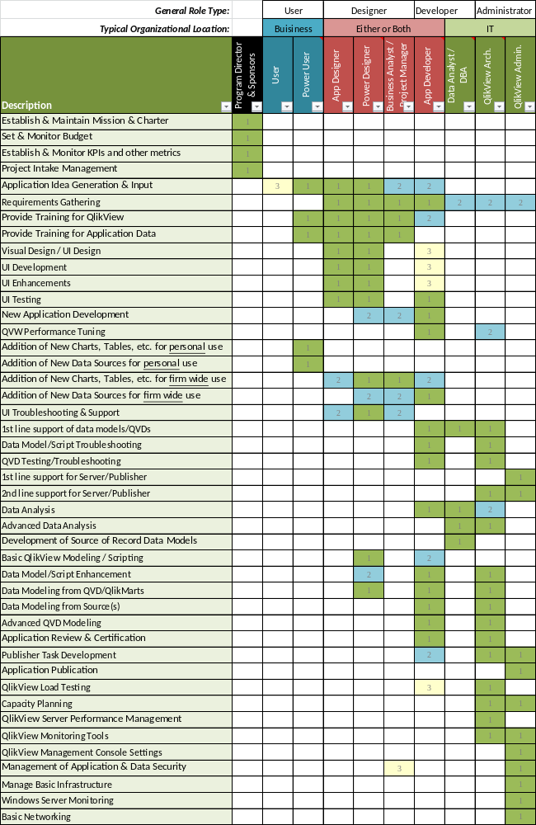

Team Structure
Here the QVCoE is interested in establishing guidelines for the organizational structure of the team. You will need to answer questions such as:
- Will the QVCoE be imbedded within a larger BI team?
- Will resources be dedicated to the QVCoE or share with other initiatives?
- Which roles will be ‘owned’ by IT and which will be ‘owned’ by the business?
- Can some roles be owned jointly between the business and IT?
Every corporate culture and organizational structure is different. So, there is no correct answer here but remember the ultimate goal is to empower the business whenever possible.
As you think about individual QlikView roles and how they might be positioned in the organizations, remember that it may be that more technical capable business units will take on more and more responsibility – and that is not only OK - it is preferred!
Additionally, you may find that it even varies from application to application. Enterprise wide applications which serve multiple business units are likely candidates for centralization of course. However, departmental specific applications may alternatively be developed and managed by individuals within the business unit itself.
In general, think of role ownership as a spectrum. Roles on the left are most often owned by the business units. Roles on the right are most often owned by IT. And, the roles in the middle might vary based on the situation.
Works for the Business
User | Power User | App Designer | Power Designer | Business Analyst | App Dev | Data Architect | QlikView Architect | QlikView Admin
Works for IT
Here is an example of the type of matrix that you might put together. But remember, it isn’t about rigid protocols here. It is simply about establishing a starting point for discussion so that you are not reinventing the wheel each time.
At the core the QVCoE is responsible for ensuring that they foster collaboration, reuse, and economies of scale. It is also the role of the QVCoE to foster innovation. And, if there is a person in the business unit who is passionate about playing the “App Developer” role for an application which would typically be developed by IT - let them - why not? (Of course, this doesn’t eliminate the need for certification depending on the scope of the application. See the section on Delivery Process for more detail.)
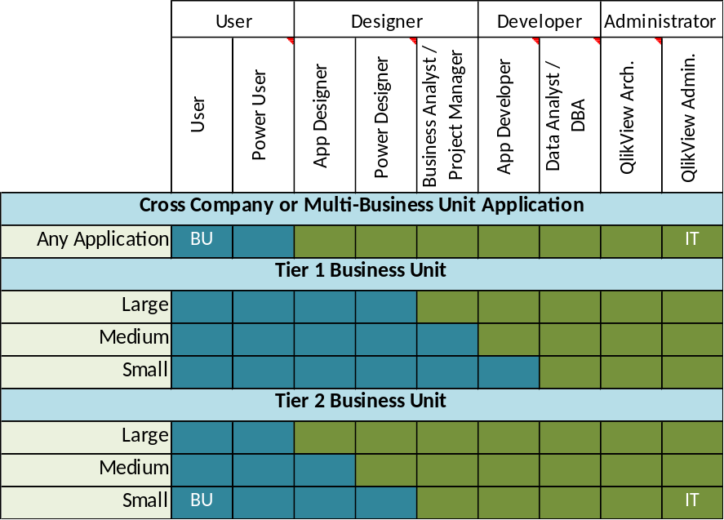

Collaboration Process
The collaboration process outlines a number of components that improve IT and the Business‘s ability to work together as a team. These items revolve around the idea of improving open lines of communication across and between individuals who might be separated organizationally.
Communication Website | - Whether it is a website, a share-point page, or some other resource, you will need a place to store your documentation and to provide others a place to go to get information about your program.
Knowledge Sharing | - Support methods for continuous communication and learning.  - Hold a monthly (or bi-weekly) meeting to communicate to all stakeholders. These meetings should be 90-120 minutes long.  - Demo new applications cross organizationally.  - Share QVCoE KPIs and other metrics to communicate progress against the program’s stated objectives.  - Provide a forum for addressing issues or concerns with current processes.  - Share best practices, tips, and tricks (mini-training)  - Discuss the status of any large initiatives.

C.
Technology Process

Delivery Process
The delivery process describes how new applications and changes to existing applications will be accepted into the production environment. In larger implementations, it will also include similar rules for other pre-production environments as well. In some cases, there might even be multiple production environments: one for IT sanctioned applications and one for the distribution of non-certified applications.
Included in this process is an outline of the type of review or testing that will be required for each type of application. For example, simple applications which will be distributed to a small work team may need no certification beyond a log for changes so that there is a record in case issues arise.
On the flip side, large complex applications which will be distributed broadly should have some type of code review. And for particularly complex implementations, this code review will include adherence to best practices and a performance profiling.
Included in this should be a discussion of how new data sources will be integrated remembering that the goal is to ensure that the business is able to move forward at full speed while you perform the necessary steps. For example, in cases where new data needs to be integrated into a central data system, this might mean that the data is staged on a basic file share while the data team works to validate and integrate the new data source. Once the data is able to be delivered by the core systems, it is as simple as changing the location in QlikView from the temporary location to the fully supported one.
The onboarding process defines how new applications will be introduced to the environment. Here we are concerned with ensuring the efficacy of the applications to deliver value to the application consumers.

Application Certification
The Application Certification process itself should be covered within the Delivery Process section of your QVCoE plan. However, here it is important to understand how you will communicate an application’s certification level to your application consumers.
By doing this, you will be able to allow for applications to be placed into production immediately in an ‘uncertified’ state in order to ensure that the business can continue to move forward without delay. However, applications which have been certified should be clearly identified as such so that your business community can build a level of trust based on how much process and governance has been applied.
Again, the goal here is to allow the business to continue to move forward while still ensuring that IT is able to perform their core role of maintaining security, scalability, performance and regulatory compliance – as well as ensuring consistency across applications.

   |  | 
Not Certified  In the event that the application is being used for a critical business decision, caution should be undertaken. | Certified with Changes  The application was previously certified. However, changes have occurred in the application and the application is awaiting re-certification. | Certified  The application has been certified. Data and calculations have been validated. Performance has been profiled and meets appropriate service levels.

Communication Plan
This process describes the mechanism that application consumers will learn about new applications and/or changes to existing applications. This can include a simple template which answers basic questions about the application as well as a path for application consumers to follow if they have questions.
Here is an example template for your reference:
Regional Store Sales Evaluator
Purpose: This application is intended for use by anyone who needs to evaluate the sales within their individual store.
SCREENSHOT
Overview: The application will allow you to evaluate sales within each store by item category (clothing, shoes, housewares), by vendor, and more. You will be able to evaluate your sales over time (weekly) and also compare your sales against the range of results from other stores from your region.
Lunch & Learn: Click here to sign up - Friday February 14th 12PM EST
Access: Access to this application will automatically be provided to all store managers. If you do not have access and feel that you should, please reach out to the application owner john.smith@yourcompany.com
Questions or Concerns: Send an email to QVCoE@yourcompany.com

Data Model Training
It is one thing to have the data, it is quite another to ensure that everyone is using the data in a consistent way. Data model training should be offered:
- For power users, designers, and developers
- For any new data source being made business-ready
- For complex data models involving multiple sources
Here you are concerned with the proper use of the data, how to use reference data, meta-data, and how to find the best source for the data that they need. You will also need to address a process for managing the definitions used in applications.
This will differ from firm to firm. In order to assist, QlikView provides the data Governance Dashboard to assist administrators with the evaluation of QlikView applications to ensure data use consistency across applications. The QlikView Governance Dashboard is available as a free download in the Qlik Market.

Application Training
QlikView is incredibly easy to use. So, for many applications it may feel like training is an unnecessary. However, in order to ensure that your business community is getting the most out of your efforts, it is important that your application consumers understand how the data should be used, what types of questions you can answer with the application, and how the application fits into the overall application ecosystem.
Here again, don’t overthink it. For most applications, this can be a 10 minute recording of your business analyst walking through common use cases within the application. The point here is to give everyone a common starting point and to ensure that the application is able to deliver as much value as possible as quickly as possible.
For more complex applications, such as investment security risk modeling application where the data will be used to make trading decisions, you may require your application consumers to receive more customized one-on-one training.

Best Practices
The section on Best Practices involves the need to create a mechanism for capturing and communicating best practices. This might include:
- templates to ensure a consistent look and feel across applications
- checklists for application certification
The following is an example of checklist items which might be required of all QlikView developers in order to ensure a consistent and stable experience for the users.
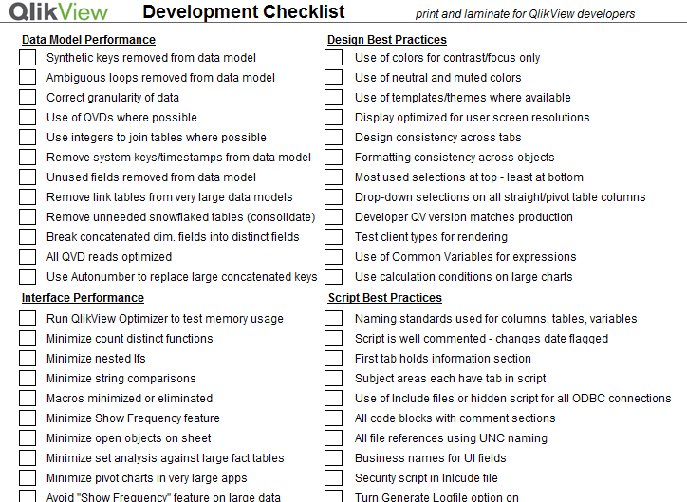

Governance Model
The governance model establishes guidelines on how you will manage the ongoing consistency and stability of the QlikView environment. Here you will outline processes and procedures for providing oversight including:
- Security audits
- Standards compliance
- Data and calculation consistency audit
  - Governance Dashboard
- System Performance
  - Systems Monitor

One way to manage these types of efforts is to great a table which outlines the various activities that the team will undertake and the days on which your team commits to completing them.
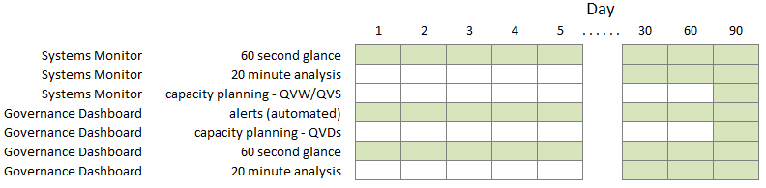

Onboarding Process
The onboarding process outlines how each new person will be brought up to speed on the system. This will vary from role to role but should include the following considerations.
Training Plan | - Each type of role within the organization should have an established training plan. What are the classes, books, or interactions that they will have to support their effective use of QlikView?  - For developers, this may include offsite training.  - For standard application consumers, this might be a simple 10 minute video.  - In addition to ‘getting started’ training, consider how you will support ongoing improvements in skills. As an example, consider a ‘tip of the week’ for users and a separate one for power users.
Onboard Mentoring | - An outline of how you will support and educate new members of the team. This could be a developer in IT or a power user in the business. But, it isn’t enough to just point them at documentation and expect them to follow the rules of engagement.  - Consider assigning each new person two mentors – if possible, one should be from a similar role and the other should be from another organizational. Encourage reasons for them to interact and establish a relationship.  - If they are regionally co-located, fund a lunch. If they are geographically dispersed you will need to get more creative.

D.
Service Management

KPIs & Metrics
The KPIs and Metrics maintained by the QVCoE should cover several areas. Metrics should be calculated over different time intervals and evaluated over time and against stated goals.
- QlikView & Application Adoption
  - Total # Production Applications (*small, medium, large, overall)
  - Total % of Application Consumers
  - QVCoE Staffing Level (FTEs, FTEs/Applications, FTEs/Consumers)
- Project Management Metrics
  - Application Development (*small, medium, large, overall)
    - Projects in Queue
    - Projects Delivered
    - Days to Delivery
    - Days to Certification
  - Change Requests
    - % Changes >24hrs
- Customer Satisfaction
- Performance & Scalability
  - Largest application (RAM)
  - Server utilization (CPU & RAM)
- License Management
  - Total by type
  - % utilized by type
*Note: one way to assign a quick complexity score to your applications is to utilize the free Governance Dashboard.

Support Model
The support model for the QVCoE will cover a variety of areas.
- Where can application consumer’s go for help using a QlikView application?
- Can Power Users tap into QVCoE developers for guidance?
- How will uncertified applications be supported?
Business Users
- How do users get trained/enabled on the applications?
- What documentation and training videos are available?
- How does somebody get granted access to applications?
- What communities are available for them to answer their own questions?
- How do users log a support ticket?

Shared Services
- Are these applications being built using proper standards and best practices?
- Who triages Level 1 support requests?
- What’s the engagement process and SLAs?
- What’s the escalation process?

Service Level Agreements
This is the agreement that you have with your user community on how you respond to requests or issues. These agreements may vary from instance to instance. For example, you will most likely have very different service level agreements for your sandbox/test environments than you would for production. Even in production, you may have different agreements for different applications and even different time windows.
Commonly covered under the topic of Service Level Agreements (SLAs) are metrics around service availability and performance. However, there are many other considerations.
- Production Service Availability
- Production Service Performance
- New user on-boarding
- Small Change Requests
- Project Scoping Request Turnaround

Service Chargeback
Of course service chargeback methods vary from firm to firm and like so many other sections of this document, there is no right answer are different ways to do this. However, you will need to determine how your QlikView efforts will be funded on an ongoing basis.

One common method of determining the cost of the service chargeback is to simply take the projected associated costs and to divide it by the projected number of billable units. An example of billable units is FTE-months where each person who uses the system is charged for each month that they have access (whether or not they use it). Even this isn’t quite as straight forward as it might seem as there are other questions which will need to be answered.

- Will named users and CAL users be charged the same cost?
- Will the cost of development services be shared by all users or will projects be funded by letters of agreement (LOAs)?
  - Large projects are scoped and funded individually while small development efforts and change requests are funded out of the general service account.

Common associated service costs
- Server Hardware
  - Initial capital/expense for necessary server hardware
  - Internal or external chargebacks for virtual servers
- Server Management
  - Internal chargebacks for OS/hardware management including internal network, firewall, datacenter and other charges.
- Software Licensing
  - Named users vs. CALs
  - Server license fees
- QVCoE Staffing
  - Contractors and FTEs associated with the QVCoE
  - Data Services Contractors and FTEs
- Overhead
  - Management
  - Strategic funding

Appendix

Role Descriptions
The following pages provide more detailed descriptions for some of the key roles that will need to be staffed for your QlikView Center of Excellence. These are the roles with very distinct QlikView skills required including the designer, developer, architect and administrator.

QlikView Developer
QlikView Developers are QlikView professionals who can build the data logic, data models and interfaces for QlikView dashboards. The outline below shows the main skill sets, training and responsibilities that are usually needed for this role.

Skill Sets:
QlikView User Interface Knowledge | Charts, graphs, tables, expressions, properties, tabs, layout
QlikView scripting knowledge | Understanding of QlikView scripting, data analysis and QlikView data models
SQL/Data knowledge | data acquisition and manipulations skills in SQL-compliant or other data sources.
QVD knowledge | Understanding how QVDs work with QlikView to provide a scalable, reusable, metadata-driven data layer

Training: http://www.qlikview.com/us/services/training/recommended-courses
QlikView Designer Version 11  Instructor-led two (2) day course | QlikView Designer is a scenario based course covering the fundamentals required to get started building QlikView applications. The course is a mixture of demonstrations and hands-on exercises.
QlikView Developer Version 11  Instructor-led three (3) day course | Knowledge of the data model, creation of the proper data connections and scripting fundamentals are critical to creating QlikView documents that provide your organization with powerful business discovery tools.
Advanced Topics in Design and Development  Instructor-led two (2) day course. | Advanced Topics in Design and Development is a specialized course for experienced QlikView Designers and Developers. To benefit from this course you should have at least six months of QlikView document development experience. The course takes you through a combination of demonstrations and exercises to master Set Analysis, other advanced expressions, data modeling, performance and design concepts and incremental data loads.

Key Responsibilities:

- Data requirements gathering

- QVW performance tuning
- SQL queries
- QVD building
- QlikView scripting
- UI testing (unit and user)
- QlikView data model best practices
- Data testing

QlikView Designer
QlikView Designers are QlikView users who can build the user interface for QlikView applications (QVWs). The outline below shows the main skill sets, training and responsibilities that are usually needed for this role.

Skill Sets:
QlikView user interface knowledge | Charts, graphs, tables, expressions, properties, tabs, layout
Visual design skills | Best practices in visual design, use of color, space, content to maximize adoption and use
Requirements gathering | ability to sit with business users and determine requirements for UI, KPIs, navigation paths, look and feel
Basic QlikView data skills | needed in case they are adding spreadsheets or other flat files to existing data models

Training: http://www.qlikview.com/us/services/training/recommended-courses
QlikView Designer Version 11  Instructor-led two (2) day course | QlikView Designer is a scenario based course covering the fundamentals required to get started building QlikView applications. The course is a mixture of demonstrations and hands-on exercises.
Data Visualization Design & Best Practices Using QlikView  Instructor-led two (2) day course. | Data Visualization and Design Best Practices Using QlikView introduces you to the topic of visualization; the practice of creating images that make sense of all that data and enable insight.

Key Responsibilities:

- UI requirements gathering
- UI design
- UI development
- Following code promotion process
- Training end users
- UI Support for End Users
- UI Enhancements
- UI testing (unit and user)
- Conducting design reviews of UI
- Documenting changes and enhancements

QlikView Administrator
QlikView Administrators are QlikView professionals who manage the day-to-day operations of a QlikView deployment. The outline below shows the main skill sets, training and responsibilities that are usually needed for this role.

Skill Sets:
QlikView Server knowledge | understands how QlikView Server works and interacts with other QlikView components
QlikView Publisher knowledge | understands how QlikView Publisher works and interacts with other QlikView components
QlikView Component knowledge | understands all components of QlikView and how they interact on Server and Publisher
Infrastructure knowledge | basic knowledge of Windows servers and settings, networks, databases and other IT infrastructure

Training: http://www.qlikview.com/us/services/training/recommended-courses
Server Publisher Version 11  Instructor-led three (3) day course | The Server Publisher course is for System Administrators to develop and sharpen their skills in product installations, deployment methods and security integration with the QlikView platform.
System Management Overview  On demand online 60 minutes | This e-learning course is designed to give a quick overview of QlikView Server and its importance in the QlikView platform architecture.

Key Responsibilities:

- Infrastructure requirements gathering
- QlikView Server settings
- QlikView Publisher settings
- QlikView Management Console
- QlikView Systems Monitor App
- QlikView Governance Dashboard
- Capacity Planning
- Windows Server monitoring
- Code Management & Code Promotion
- Documenting changes and enhancements

QlikView Architect
QlikView Architect is an optional role for larger deployments. This professional is the master designer & owner of QlikView QVDs and QVWs. The outline below shows the main skill sets, training and responsibilities that are usually needed for this role.

Skill Sets:
QlikView user interface knowledge | charts, graphs, tables, expressions, properties, tabs, layout
QlikView advanced scripting | understadning QlikView scripting, data analysis and QlikView data models
SQL/Data knowledge | data acquisition and manipulations skills in SQL-compliant or other data sources.
Advanced QVD knowledge | tunes and optimizes QVD layer, including metadata, audit checks, monitoring and business rules.

Training: http://www.qlikview.com/us/services/training/recommended-courses
QlikView Designer Version 11  Instructor-led two (2) day course | QlikView Designer is a scenario based course covering the fundamentals required to get started building QlikView applications. The course is a mixture of demonstrations and hands-on exercises.
QlikView Developer Version 11  Instructor-led three (3) day course | Knowledge of the data model, creation of the proper data connections and scripting fundamentals are critical to creating QlikView documents that provide your organization with powerful business discovery tools.
Advanced Topics in Design and Development  Instructor-led two (2) day course. | Advanced Topics in Design and Development is a specialized course for experienced QlikView Designers and Developers. To benefit from this course you should have at least six months of QlikView document development experience. The course takes you through a combination of demonstrations and exercises to master Set Analysis, other advanced expressions, data modeling, performance and design concepts and incremental data loads.

Key Responsibilities:

- Data requirements gathering
- SQL queries
- QlikView scripting
- QlikView data model best practices
- Application Architectures
- QVW performance tuning
- QVD building
- Data model tuning
- QlikView load testing
- Capacity planning (data, apps, licenses, RAM, CPU

Version Log

Date | Summary | Description
1/1/2014 | Initial Draft | Initial draft released to internal resources for review and feedback.
1/13/2014 | Second Draft | The first draft released to the QlikView community group.
3/11/2014 | First non-Draft Version | Includes minor updates based on first round of feedback.

