    - Stop Qlik Sense Repository Service (this will also stop the other services)
    - Open Microsoft Management Console (MMC). Important: Run this as the account configured to run the services (Run as... )
    - Add snap-in for Certificates: My user account and Local Computer account
    - In Certificates - Current User > Trusted Root Certification Authorities > Certificates, delete the certificate created by QlikSense, issued by your computer, computer.domain-CA
    - In Certificates > Current User > Personal > Certificates, delete the certificate named QlikClient
    - In Certificates (Local Computer) > Personal > Certificates, delete the certificate issued by computer.domain-CA.
    - Start Qlik Sense Repository Service and verify it created the new certificates
    - Start the rest of the services

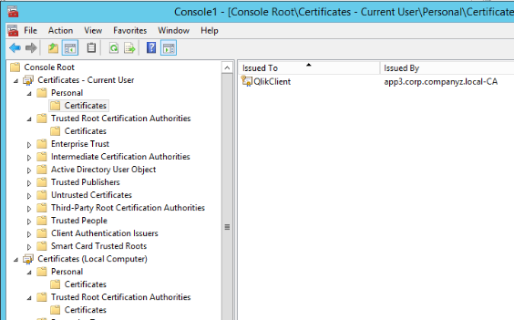

There's no need to do a full reinstall to propagate new certificates. They are being created by the Repository Service automatically if missing.

