Splits and Benchmark table in Finance
Purpose: Currently we show the splits and benchmark table in 2 formats:
- HR – showing Variance: PY
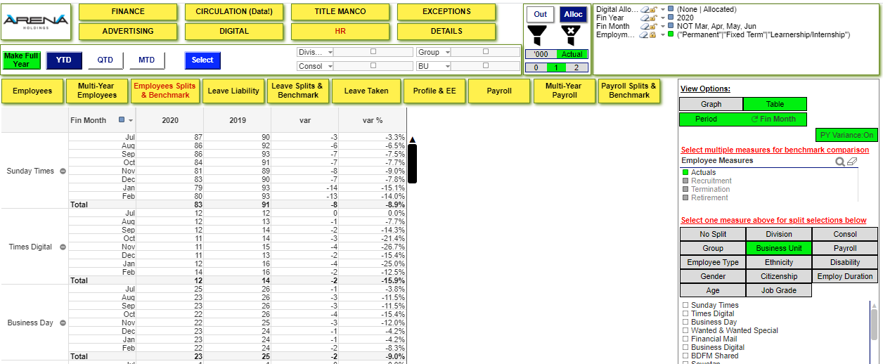
- Finance – showing Variance: Off
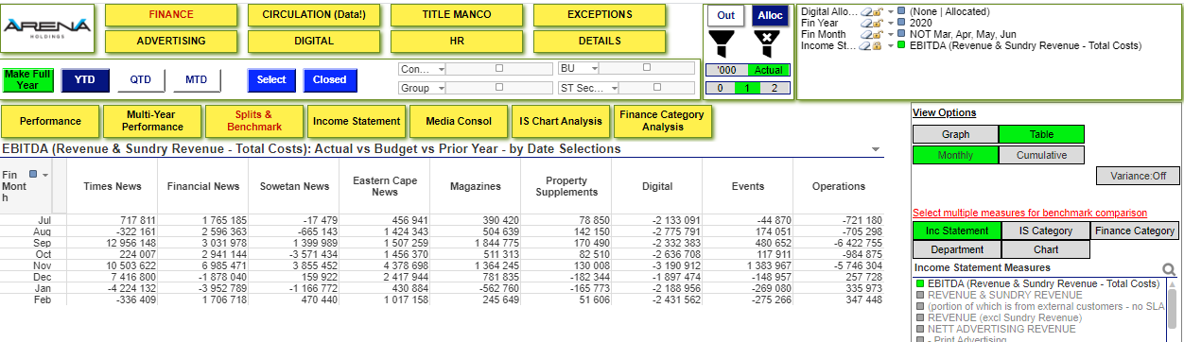

Task
- Adjust the layout of the tables as follows:
Variance: Off:
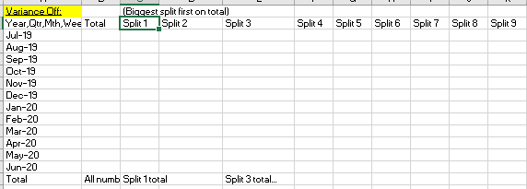
- Variance: On/PY/or Bud:
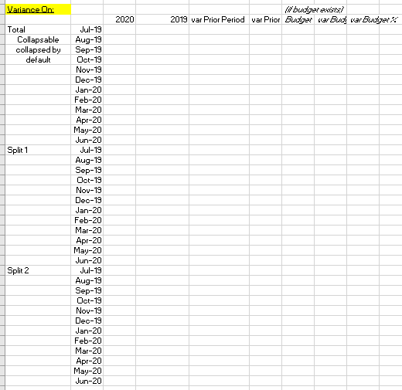
- In the above, the Splits are one of: 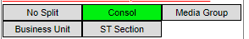with the items in the lists being the entries
- The timeframes for Finance is Monthly (although in all other sections of the model, this is determined by this: 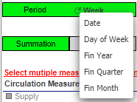
By default, collapse the months so it looks similar to this in HR (but with a Total row at the top): 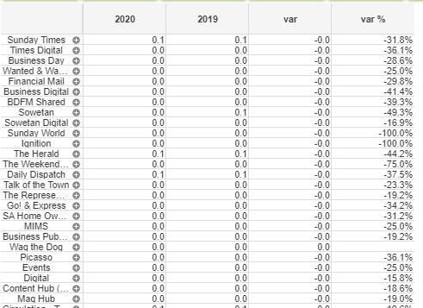
- Sort order of the splits is biggest to smallest.
- Do this for Monthly and Cumulative

