Drill UP Issue
Hi Team,
I notice in drill up is not working in Pivot if we use enable condition on the dimension objects.
For example:
I have the data with hierarchy Year->Half Year->Quarter->Month.
I created Drill down group “TimePeriod” with hierarchy level (Year->Half Year->Quarter->Month)
I created pivot keeping Country in the row and the “TimePeriod” group in the column
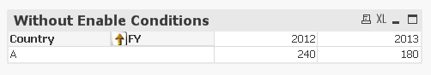
I click on the drill down on FY It drills the data one level below
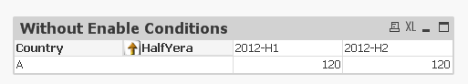
And if I click on drill up it working fine
If I keep enable condition on the country and not showing Country in the pivot as below
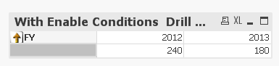
If I click on drill down in drilling the data one level down
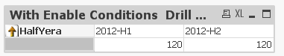
And if it try to drill up it is not working.
Attached is the qvw file 

load * inline
[FY,HalfYera,Quarter,Month,Country,Value
2012,2012-H1,Q1,M1,A,10
2012,2012-H1,Q1,M2,A,20
2012,2012-H1,Q1,M3,A,30
2012,2012-H1,Q2,M4,A,10
2012,2012-H1,Q2,M5,A,20
2012,2012-H1,Q2,M6,A,30
2012,2012-H2,Q3,M7,A,10
2012,2012-H2,Q3,M8,A,20
2012,2012-H2,Q3,M9,A,30
2012,2012-H2,Q4,M10,A,10
2012,2012-H2,Q4,M11,A,20
2012,2012-H2,Q4,M12,A,30
2013,2013-H1,Q1,M1,A,10
2013,2013-H1,Q1,M2,A,20
2013,2013-H1,Q1,M3,A,30
2013,2013-H1,Q2,M4,A,10
2013,2013-H1,Q2,M5,A,20
2013,2013-H1,Q2,M6,A,30
2013,2013-H2,Q3,M7,A,10
2013,2013-H2,Q3,M8,A,20
2013,2013-H2,Q3,M9,A,30]

Thanks & Regards,
MVV Satish.

