Deployment Steps

- Copy all the QVWs and data files from your Local Desktop to Publisher Server (MPQVPUBDEV). Make sure that you should have same folder structure on Publisher Server (MPQVPUBDEV) and Relative Path was checked during the load of QVWs.

- Folders on Publisher Server (MPQVPUBDEV) are mapped under QDS on Source Documents Tab in Qlikview Management Console (QMC) so our applications will be visible in Source Documents Tab.

- Now we create a Task for the application so that QVW can be updated on server and distributed to users through Access Point

1. Click on the Green button with white plus sign to create a task. Images below will take you through different steps in Task creation

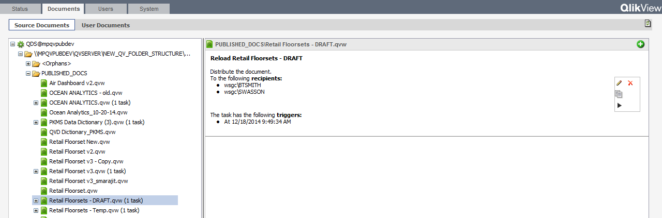

2.

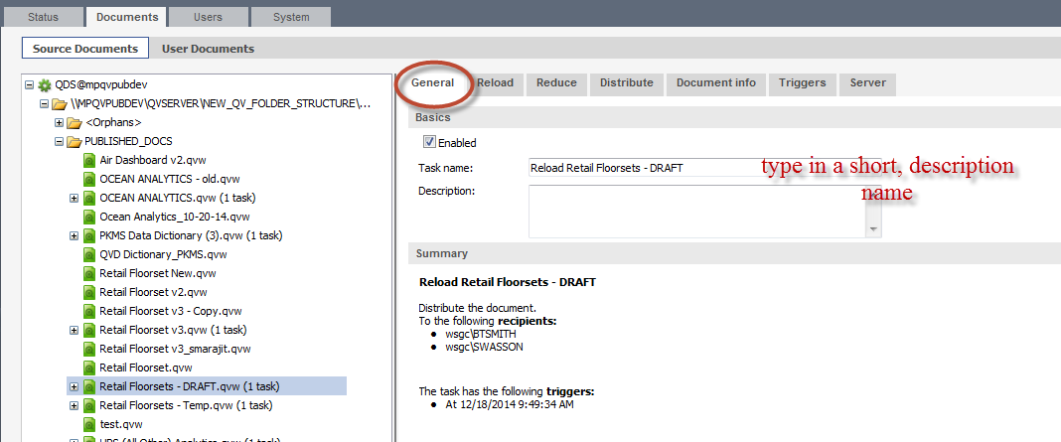

3.

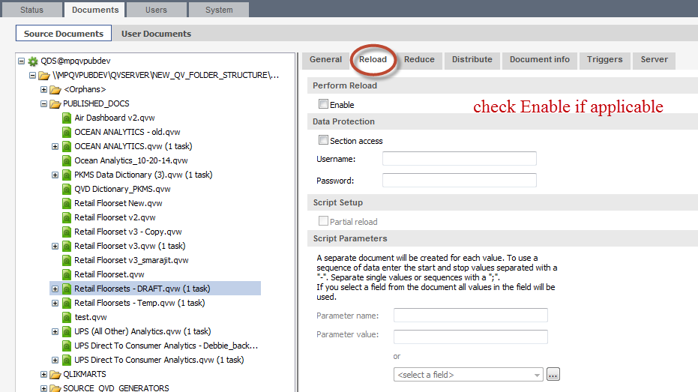

4. Reduce help in giving different level of access to different users

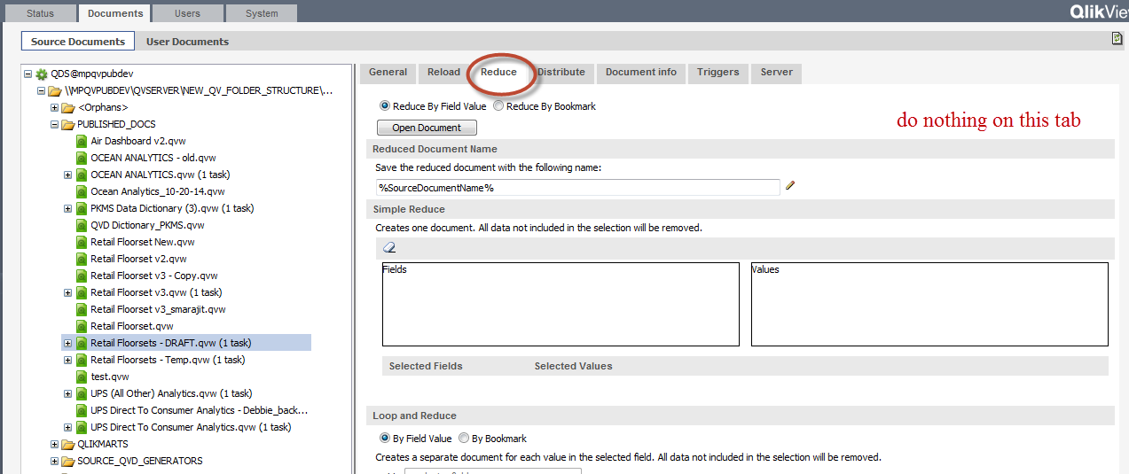

5. In this step, we select Server Name, Mounted folder Name, and Users. Once the task runs, file moves from Source Documents to mounted folder and all the files in mounted folders can be accessed from Access Point now. Mounted folders are set up on MPQVSRVDEV server.
P.S.: Systm>Setup>Folders takes us to location where Paths for Root and Mounted Folders can be defined. We can also see those files under User Documents Tab. Moving of files from Source Documents Tab to Mounted Folders and User Documents Tab is done by console itself.

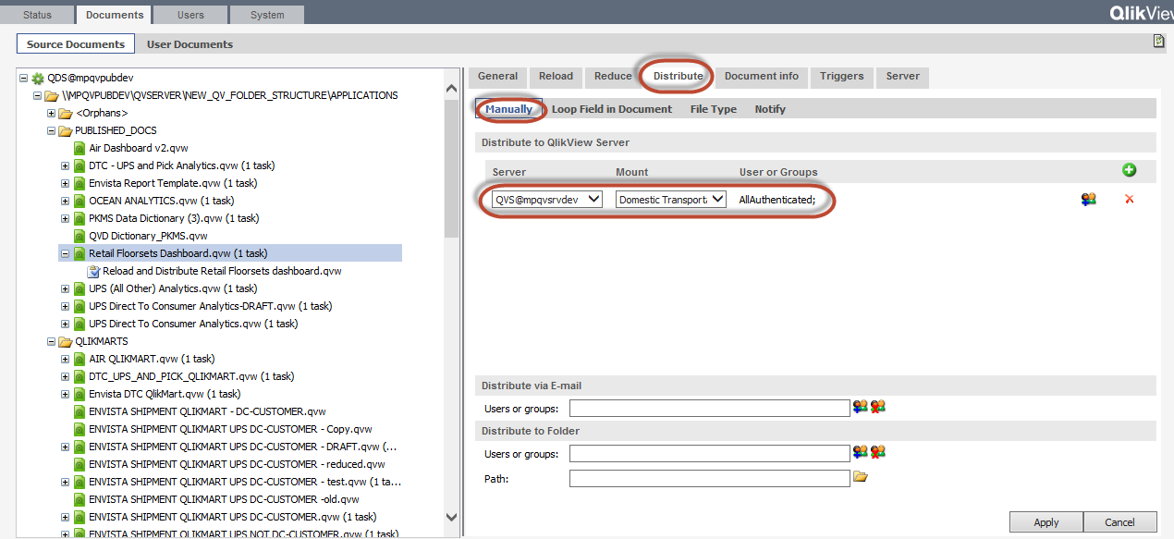

6.

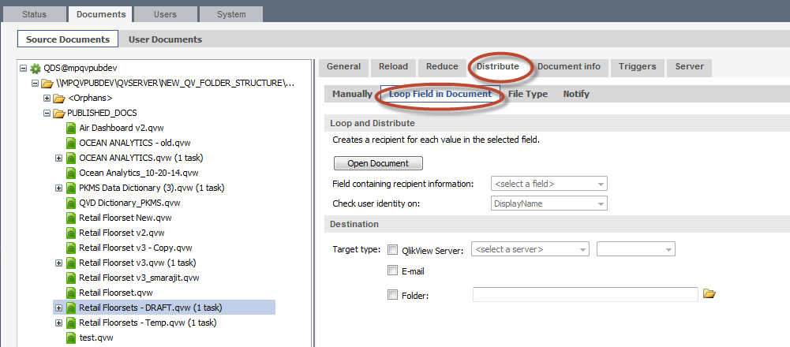

7.

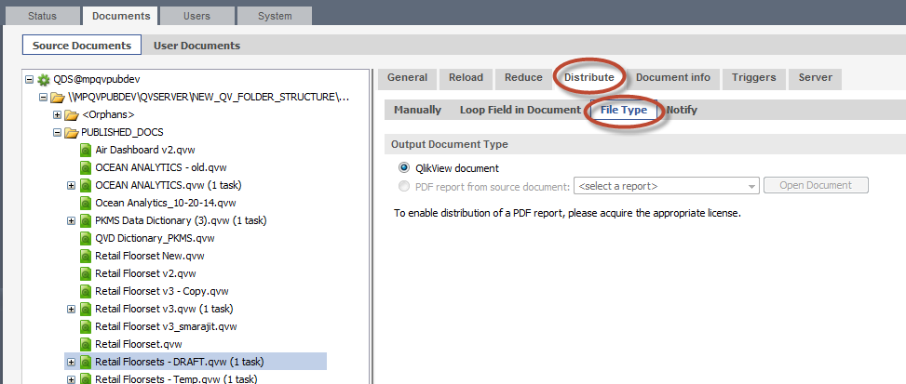

8.

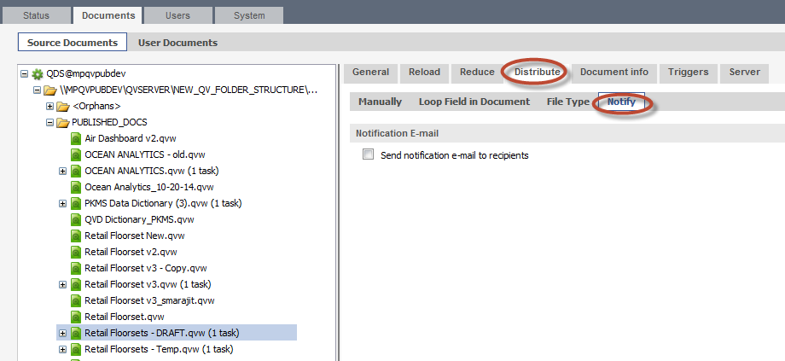

9.

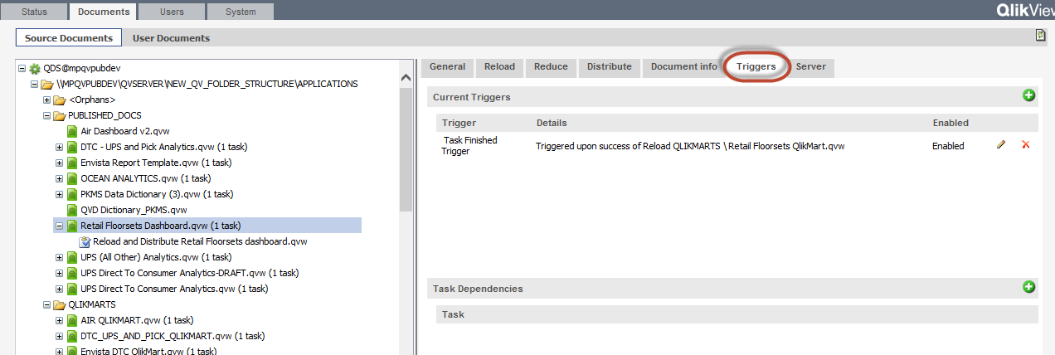

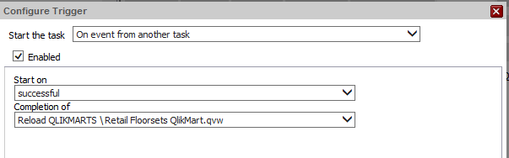
10.

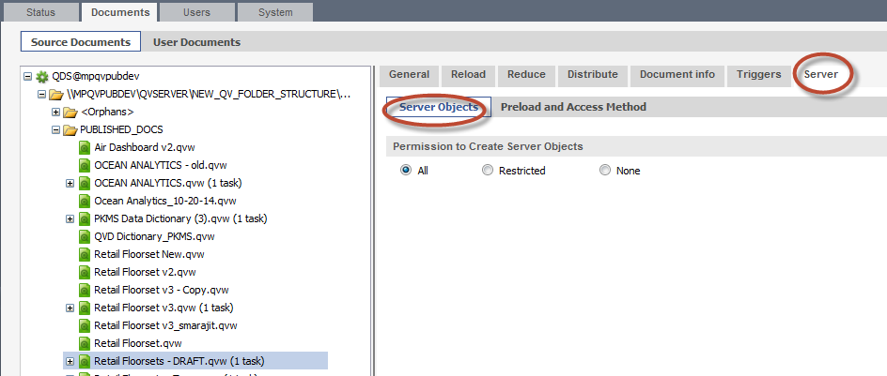

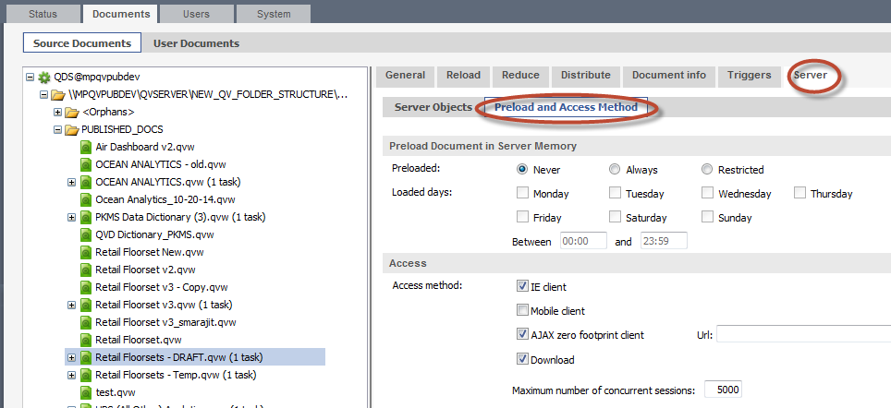

11.

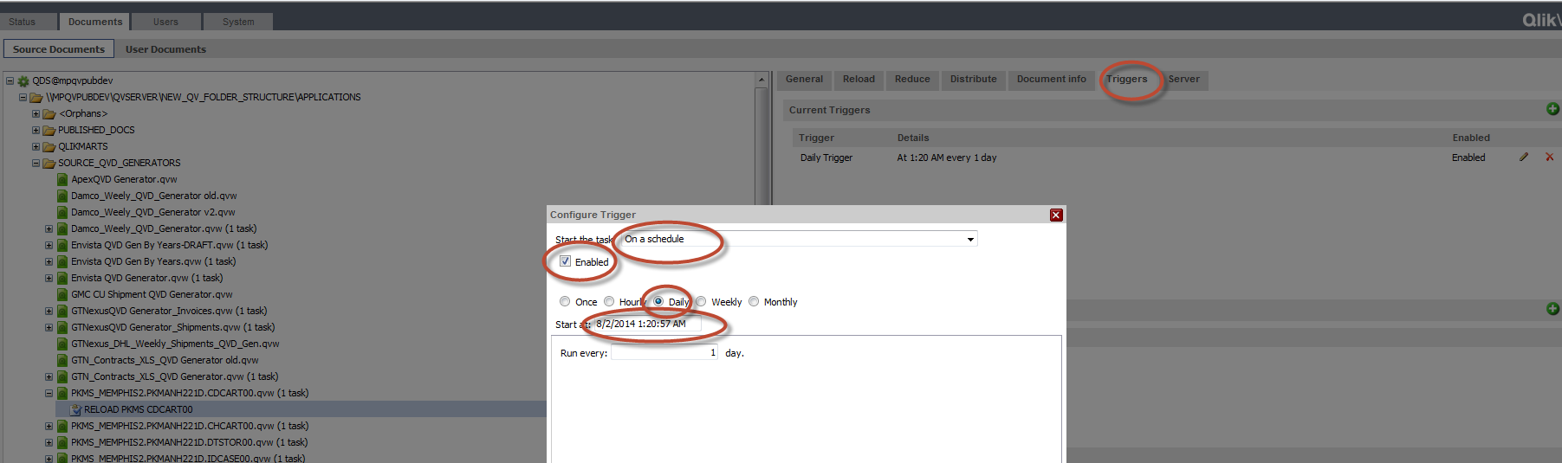

12. Once the task is created click on the triangle to reload the file

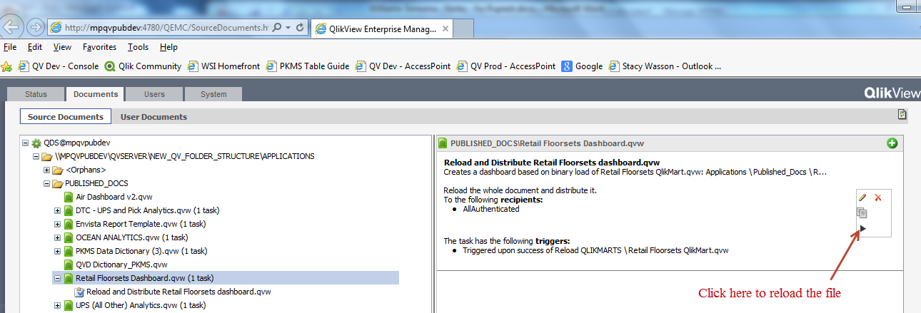

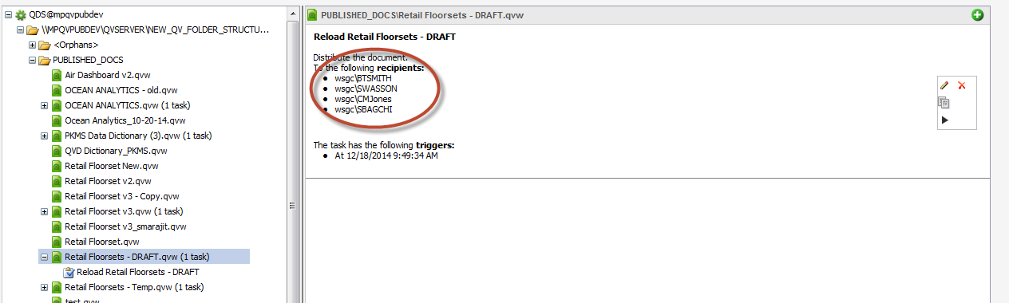

Once the task is created and QVW is reloaded, then files are automatically distributed to mounted folders (mounted folders sit on server) and files in mounted folders can be seen on Access point and under User Documents.

Removing QlikView Files from Server

Do NOT remove QlikView documents until the tasks for them have been deleted - otherwise, you will have “orphans”
