Installing the Full Oracle OLEDB & ODBC Drivers

To use OLEDB connections to oracle the OLEDB install needs to be extracted from the full Oracle Client installer. The full client installer is around 600MB but most of the content is not required, the same installer can be used for OLEDB and ODBC install.
This guide assumes a 64bit version of either Windows 2008 Server or Windows 7.

To start, download the Win 64 client installer from this URL (2nd file on the list)
http://www.oracle.com/technetwork/database/enterprise-edition/downloads/112010-win64soft-094461.html
or Google this file name:
win64_11gR2_client.zip
Extract the Client folder in the zip file to a temporary location
In the Client folder, run the Setup.exe – on Windows 7 and 2008, Run as Administrator.

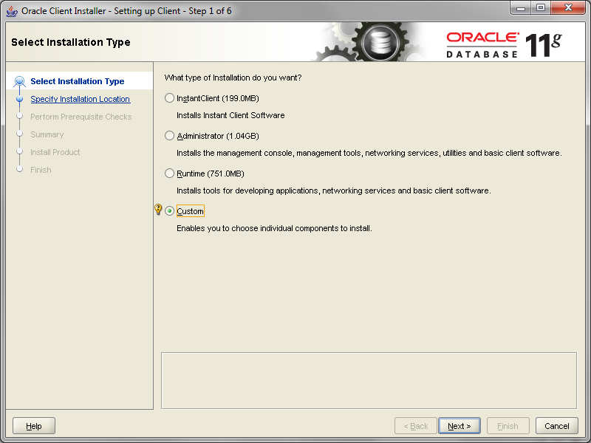
Select “Custom” for the installation type. Click “Next”.
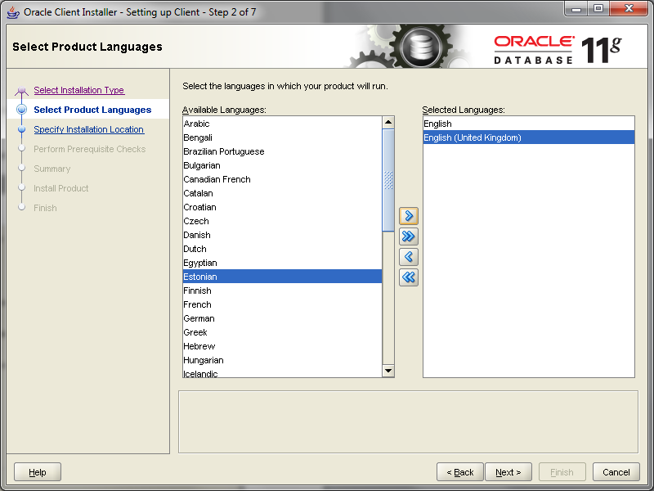
Select the correct language and click “Next”.
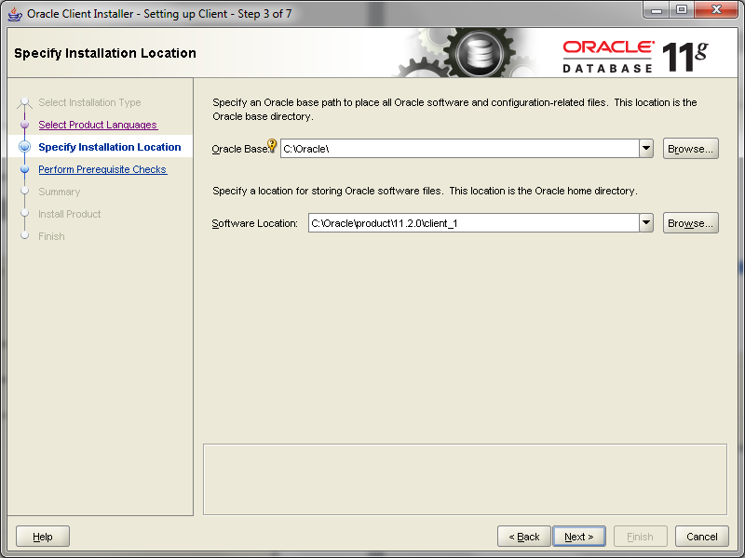
Set the paths as you want them to be eg c:\oracle and click “Next”.
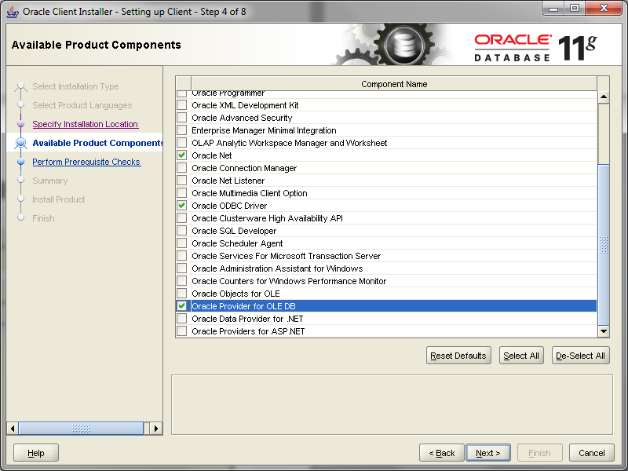
Select “Oracle Net”, “Oracle ODBC Driver” and “Oracle Provider for OLEDB” (Note: SQL*Plus can also be useful if you don’t have TOAD and want to run commands against the DB).
Click “Next”.
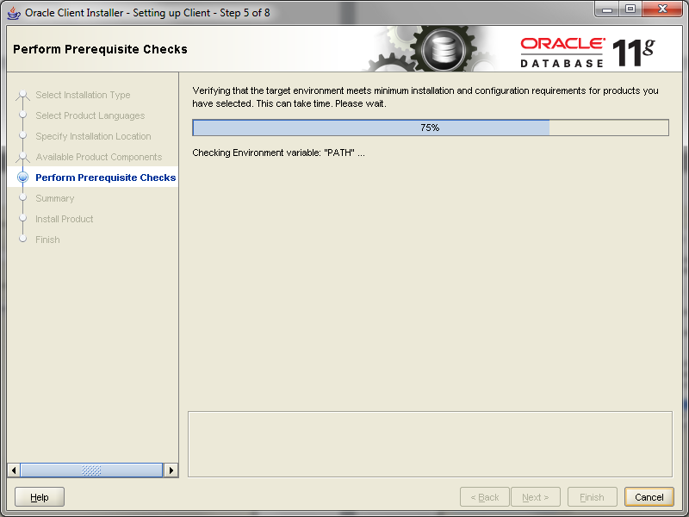
The installation checks settings.
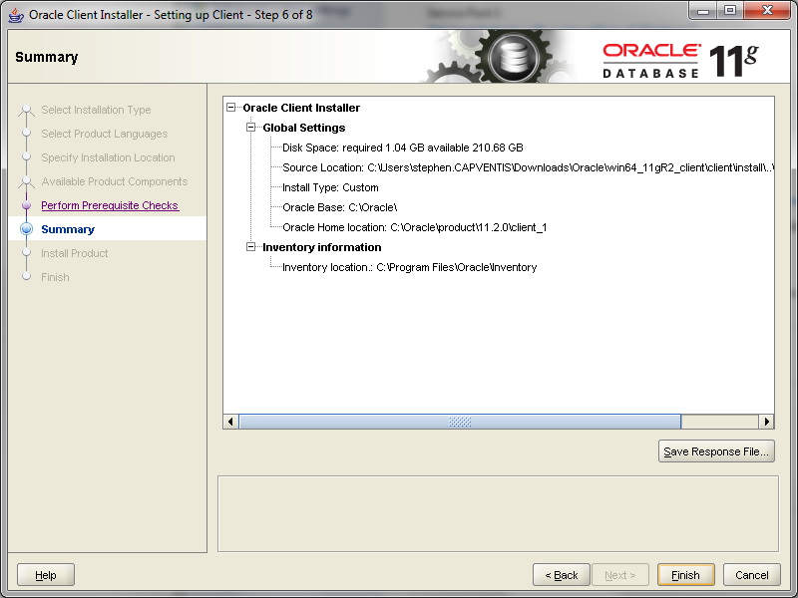
Confirm settings are OK and click “Finish”.
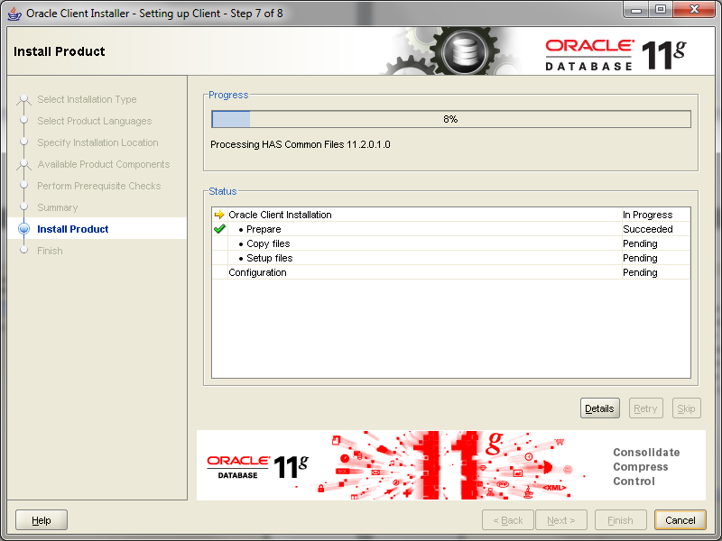
The installation continues.
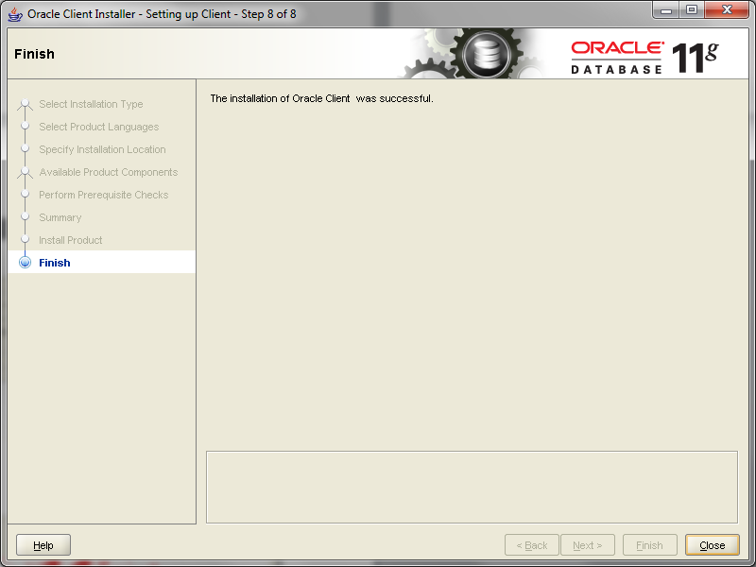
When the installation is complete, click “Close”.

The OLEDB and ODBC drivers are now installed but you need to now create the TNS names file which will tell the driver where the Oracle databases are. Ideally obtain this file from a DBA or a user who has already accessed the data you are going to use and place the file in
C:\Oracle\product\11.2.0\client_1\network\admin
If there isn’t one create a new file in notepad and save it as tnsnames.ora into the C:\Oracle\product\11.2.0\client_1\network\admin directory paste into the file the following text:

NAMEOFMYCONNECTION =
(DESCRIPTION =
(ADDRESS = (PROTOCOL = TCP)(HOST = 192.168.30.90)(PORT = 1521))
(CONNECT_DATA =
(SERVER = DEDICATED)
(SERVICE_NAME = NAMEOFMYDATABASE)
)
)

Both the ODBC and OLEDB connections can now be tested.

OLEDB
From you application try to connect to a new OLEDB data source. Pick Oracle Provider for OLEDB from the list

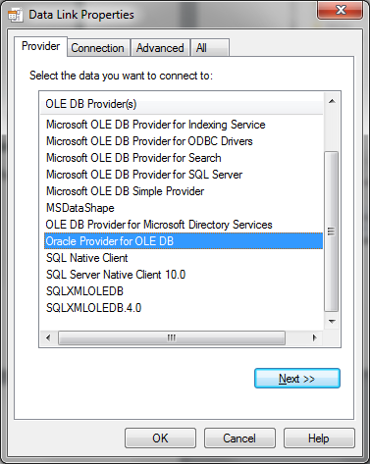

Enter the Service name from your TNSNAMES file and your user ID and password
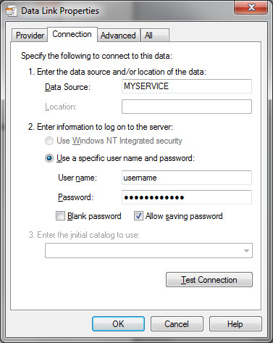

ODBC:
Create a new ODBC connection using the ODBC administrator.
Click Add
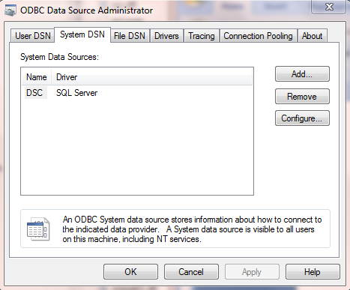

Choose Oracle
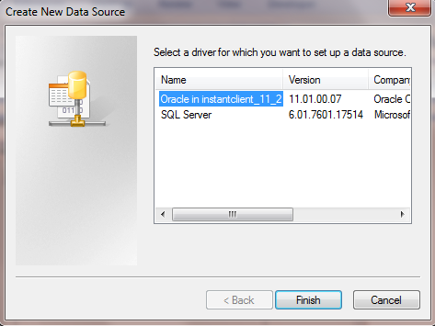
Give it a name, chose your Oracle TNS entry, provide a user name a test the connection
