Thanks,

Screen print below:

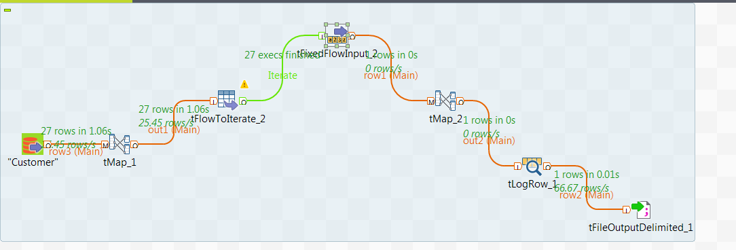

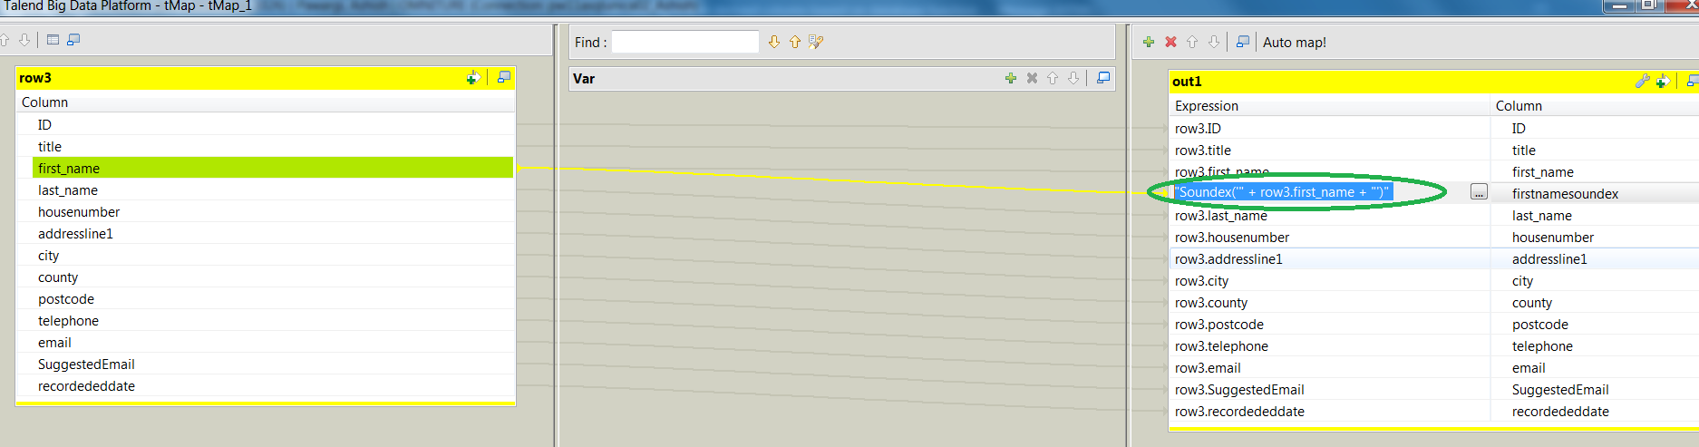

Above new column in tmap

Option for tFlowToIterate

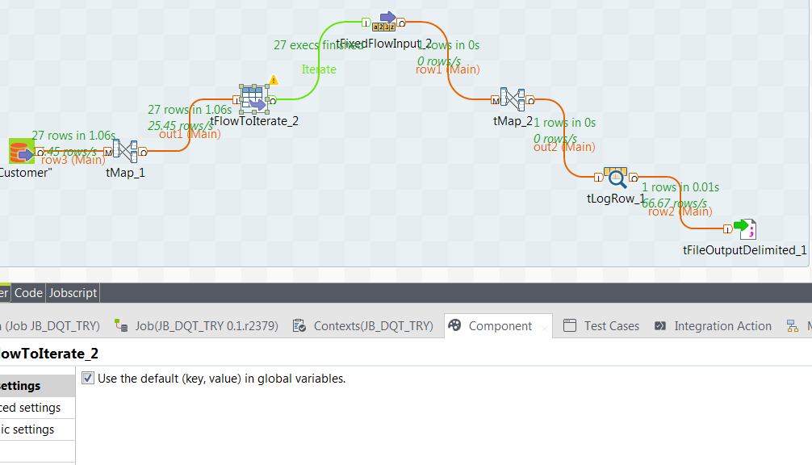

Schema updated for tFixedFlowInput and added displaysoundex with ((String)globalMap.get("out1.firstnamesoundex"))

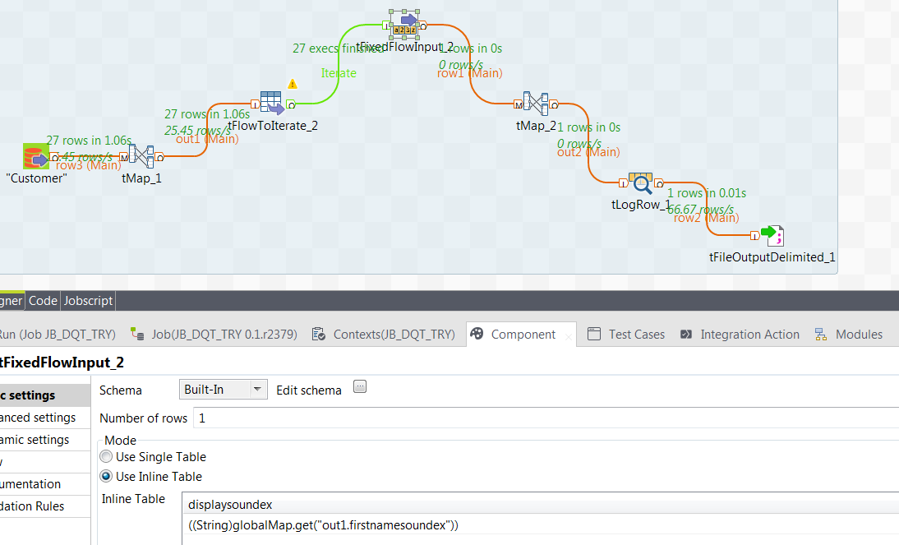
When I run the tlogrow shows

------------------.
| tLogRow_1 |
|=----------------=|
|displaysoundex |
|=----------------=|
|Soundex('Laquita')|
'------------------'

.---------------.
| tLogRow_1 |
|=-------------=|
|displaysoundex |
|=-------------=|
|Soundex('Lura')|
'---------------'

.-----------------.
| tLogRow_1 |
|=---------------=|
|displaysoundex |
|=---------------=|
|Soundex('Yuette')|
'-----------------'
.--------------.
| tLogRow_1 |
|=------------=|
|displaysoundex|
|=------------=|
|Soundex('') |
'--------------'

i.e. all rows…however the output delimited file at the end captures only the last record
displaysoundex
Soundex('')

##- Please type your reply above this line -##

