First:
After run the Analysis, I rigth click over, in this case to view valid or invalid rows:
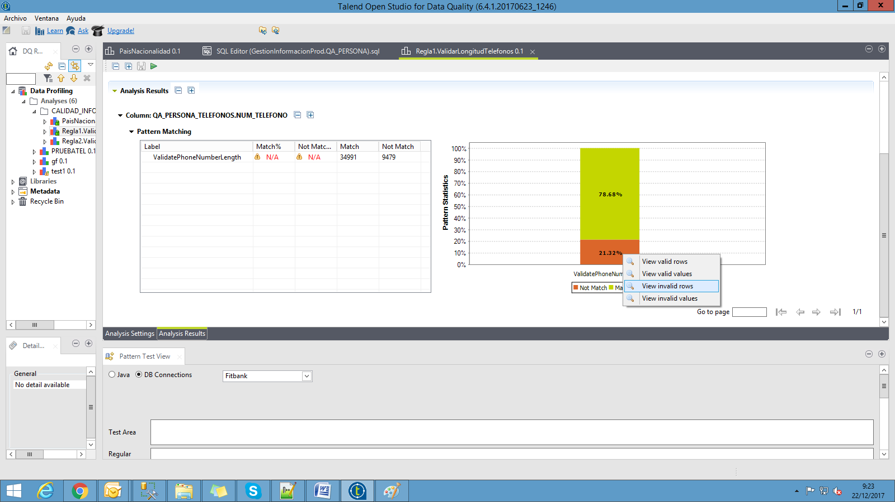
Then, in the new tab, I can see only 50 rows and I cant´t navigate between pages to see more data:
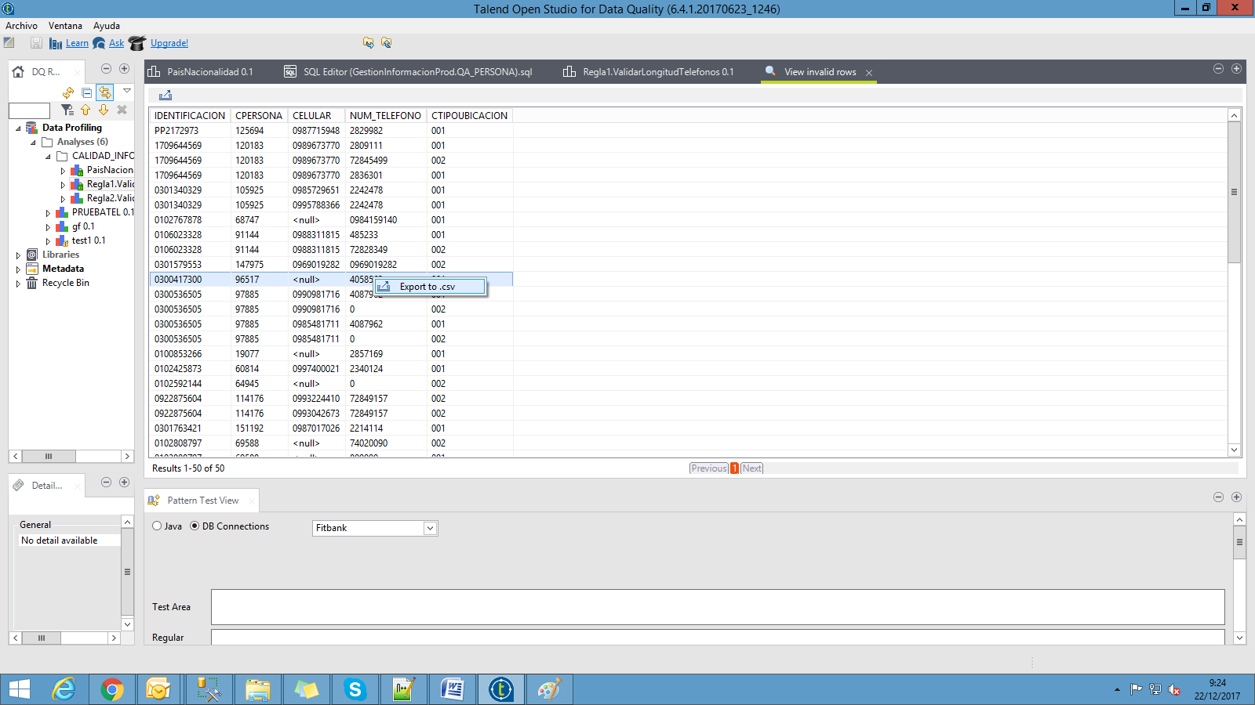
After, I right click over the results and select Export to .csv option:
Then in the new window I select export all rows options and the destination.
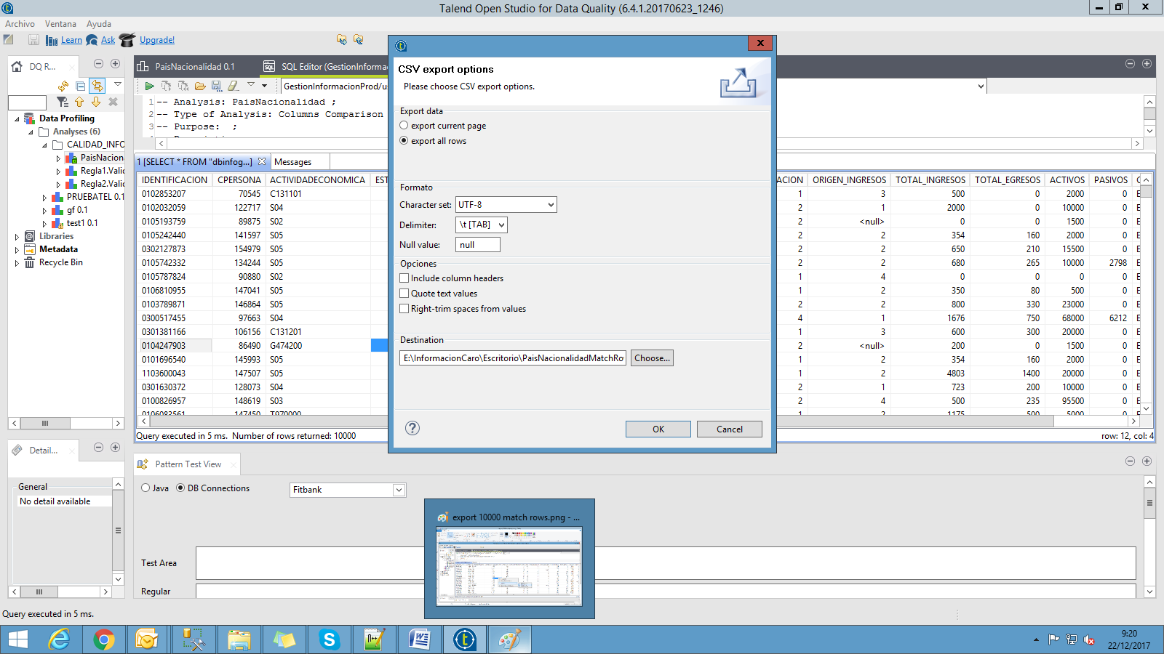
Although I select Export All Rows, in the csv result I get only the 50 rows I saw. That is the problem I have.


