Successful ARC Request/Response with Header and Body

Header:
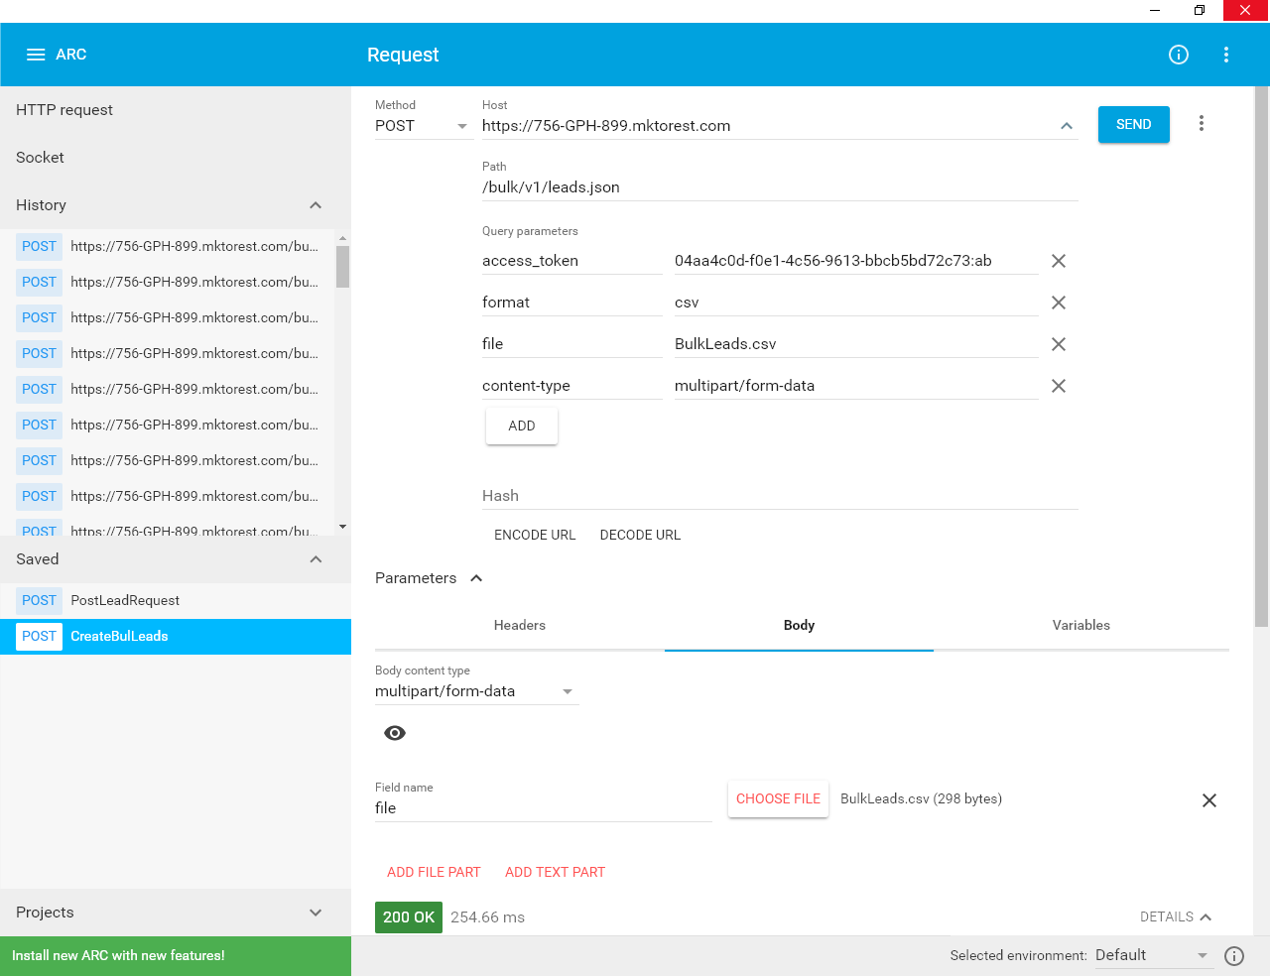

Body and Response
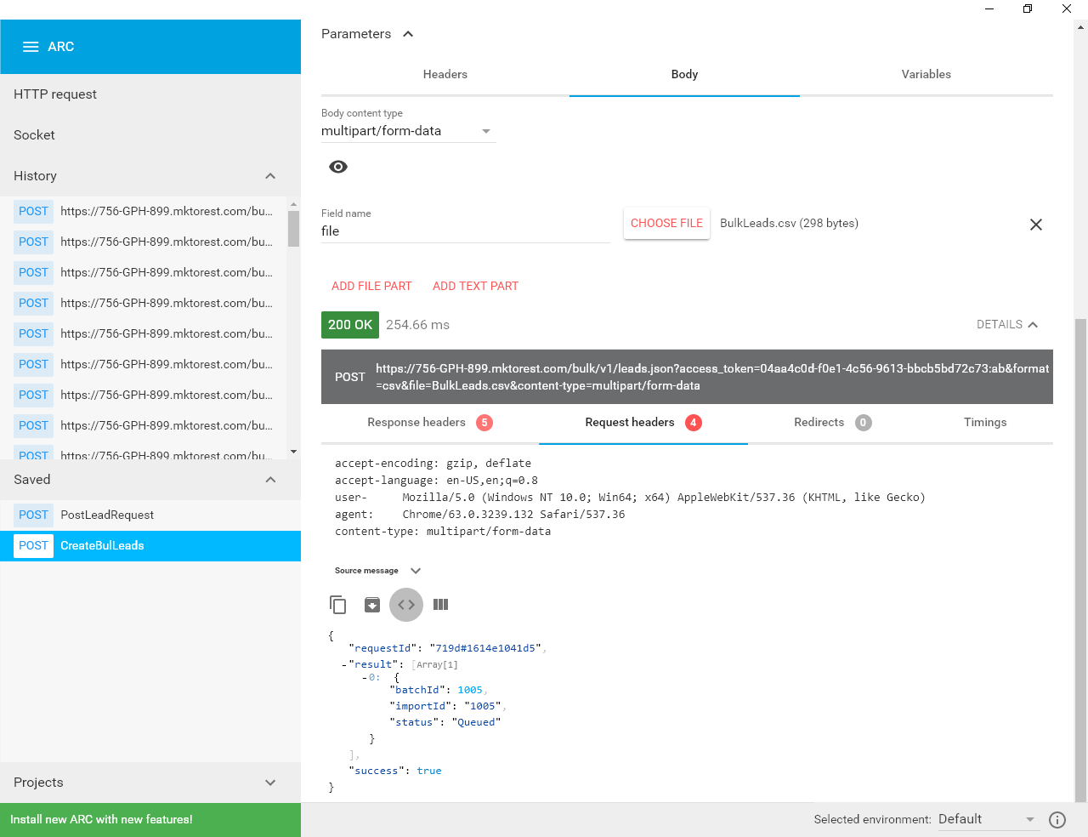

My Talend setup :
tFileFetch:Basic Setup (screen part1- HEADER)

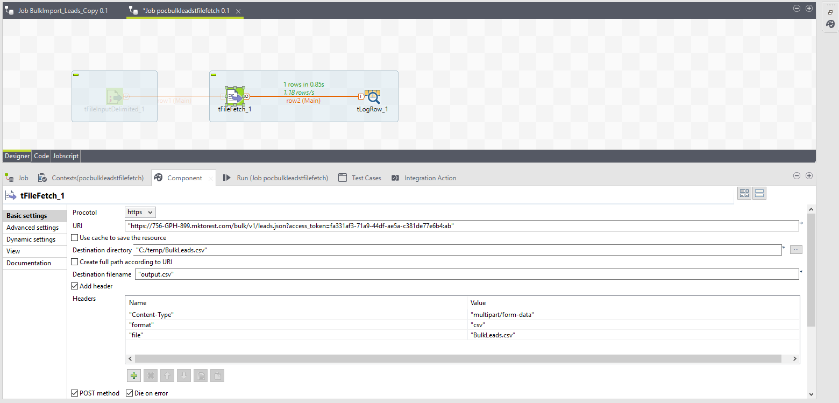

tFileFetch:Basic Setup (screen part2 - POST)

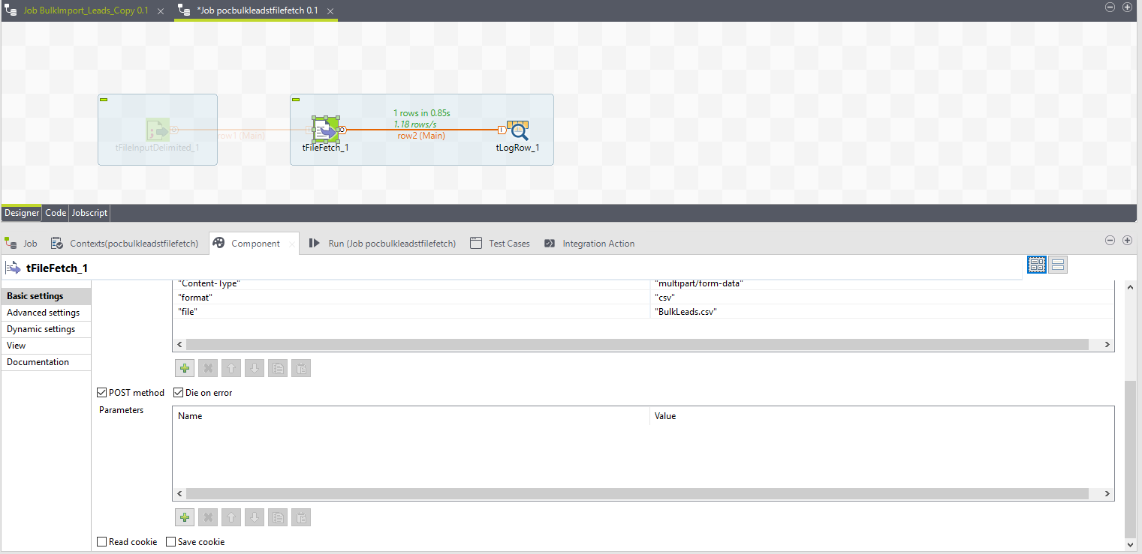

tFileFetch: Advanced tab
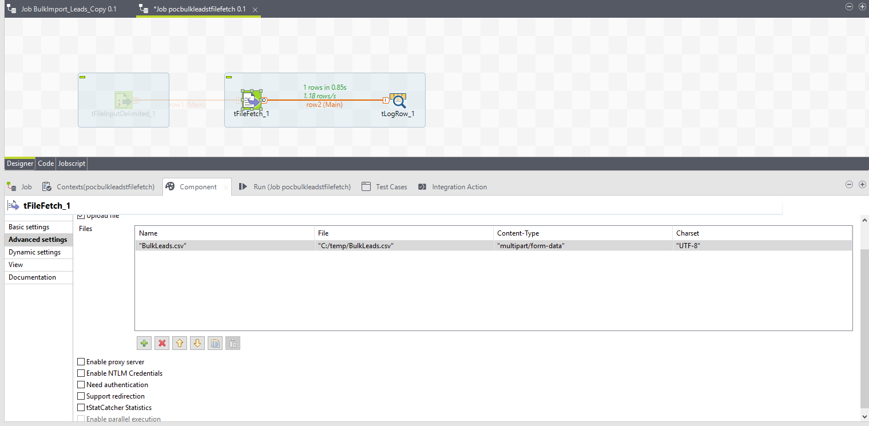

Output in console:
Starting job pocbulkleadstfilefetch at 07:15 07/02/2018.

[INFO ]: redshift_dev.pocbulkleadstfilefetch_0_1.pocbulkleadstfilefetch - TalendJob: 'pocbulkleadstfilefetch' - Start.
[statistics] connecting to socket on port 4031
[statistics] connected
[INFO ]: redshift_dev.pocbulkleadstfilefetch_0_1.pocbulkleadstfilefetch - tFileFetch_1 - Connection attempt to 'https://756-GPH-899.mktorest.com/bulk/v1/leads.json?access_token=fa331af3-71a9-44df-ae5a-c381de77e6b4:ab
[INFO ]: redshift_dev.pocbulkleadstfilefetch_0_1.pocbulkleadstfilefetch - tFileFetch_1 - Connection to 'https://756-GPH-899.mktorest.com/bulk/v1/leads.json?access_token=fa331af3-71a9-44df-ae5a-c381de77e6b4:ab' has succeeded.
Status Line: HTTP/1.1 200 OK
*** Response Header ***
Server: nginx
Date: Wed, 07 Feb 2018 12:15:25 GMT
Content-Type: application/json;charset=UTF-8
Content-Length: 112
Connection: keep-alive
[INFO ]: redshift_dev.pocbulkleadstfilefetch_0_1.pocbulkleadstfilefetch - tFileFetch_1 - Closing the connection to the server.
[INFO ]: redshift_dev.pocbulkleadstfilefetch_0_1.pocbulkleadstfilefetch - tFileFetch_1 - Connection to the server closed.
[INFO ]: redshift_dev.pocbulkleadstfilefetch_0_1.pocbulkleadstfilefetch - tLogRow_1 - Content of row 1: ,
,
[INFO ]: redshift_dev.pocbulkleadstfilefetch_0_1.pocbulkleadstfilefetch - tLogRow_1 - Printed row count: 1.
[statistics] disconnected
[INFO ]: redshift_dev.pocbulkleadstfilefetch_0_1.pocbulkleadstfilefetch - TalendJob: 'pocbulkleadstfilefetch' - Done.
Job pocbulkleadstfilefetch ended at 07:15 07/02/2018. [exit code=0] in console

Output in output.csv:
{"requestId":"d1a7#1617031281b","success":false,"errors":[{"code":"613","message":"Invalid multipart request"}]}

