- tFileInputDelimited
Advanced Settings -> Encoding set to UTF-8 (for tFileInputDelimited)
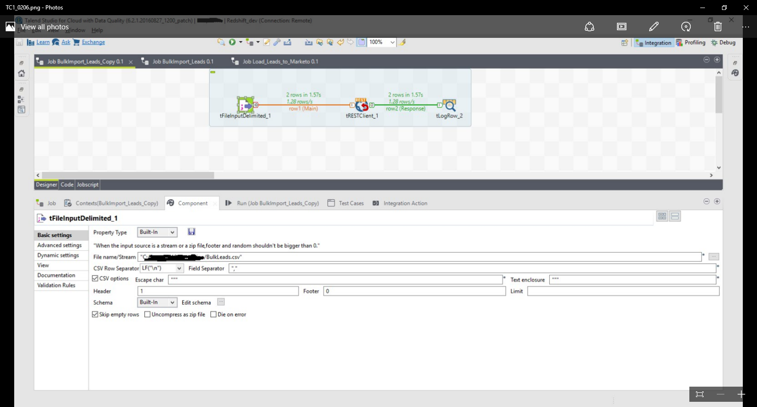

- tRestClient
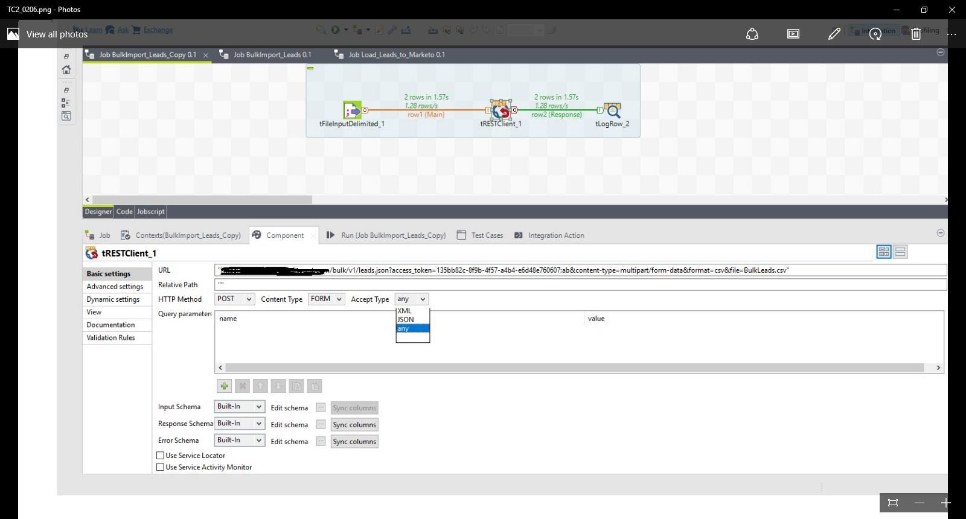

Advanced Settings of tRestClient
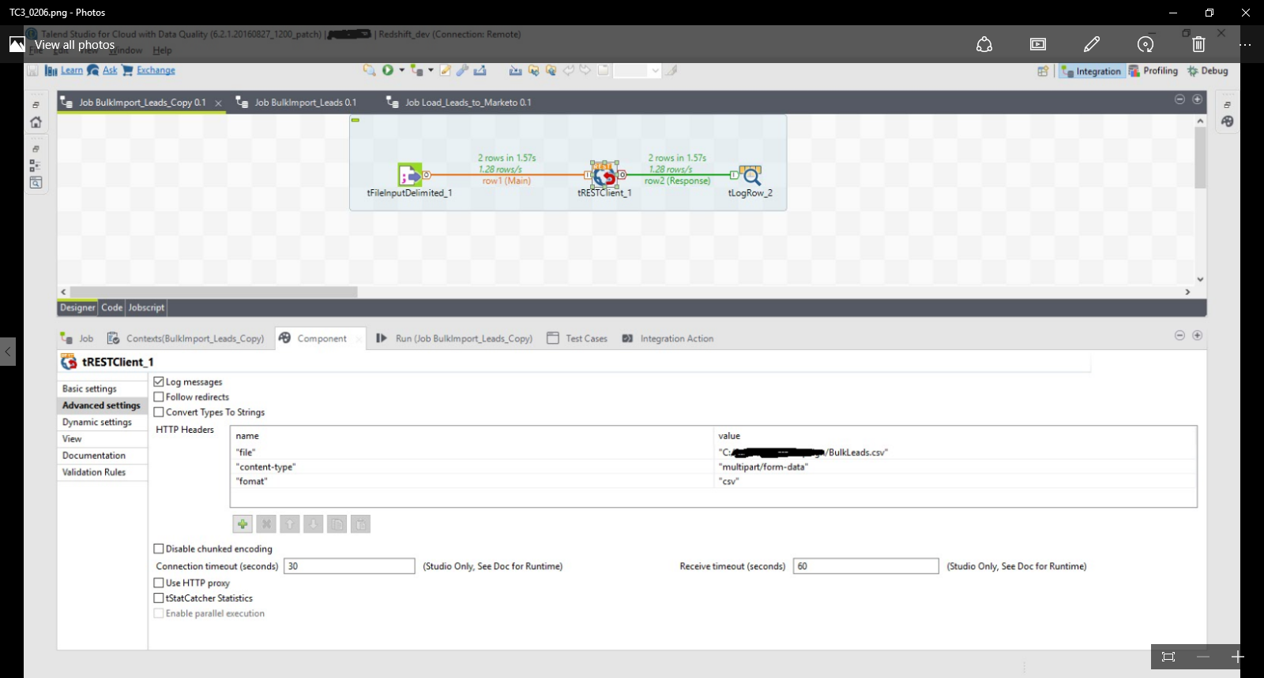

The BulkLeads.csv has following content:

custNumber,email
05109244,BNew1234test1@a.com
80592730,Bnew12ulicesvg@gmail.com

Output When I run it:
Starting job BulkImport_Leads_Copy at 16:27 05/02/2018.

[statistics] connecting to socket on port 3593
[statistics] connected
200||{"requestId":"670e#16167de5984","success":false,"errors":[{"code":"612","message":"Invalid Content Type"}]}
200||{"requestId":"17776#16167de5a70","success":false,"errors":[{"code":"612","message":"Invalid Content Type"}]}
[statistics] disconnected
Job BulkImport_Leads_Copy ended at 16:28 05/02/2018. [exit code=0]

