Job Component Layout:
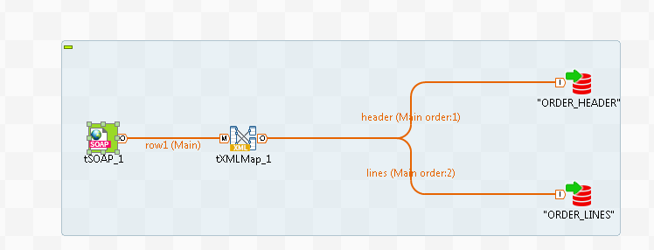

tSOAP configuration: Output in Document checked!
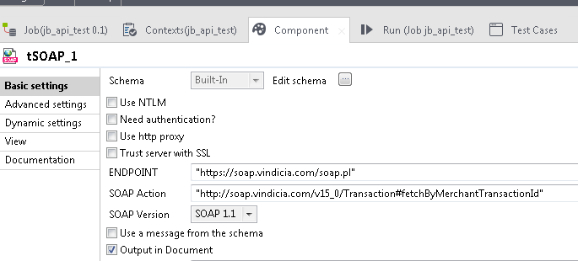

tXMLap configuration:
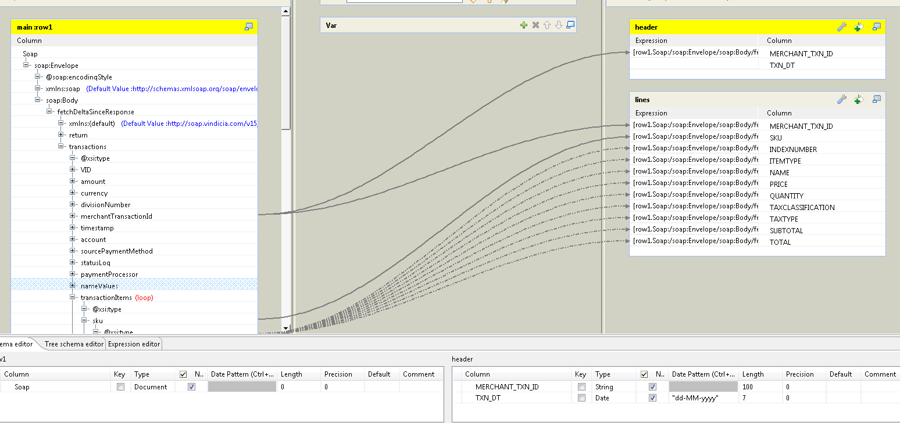
Job Run: Runs successfully – reads 1 record, but nothing is inserted into the Oracle table


