Main Job:
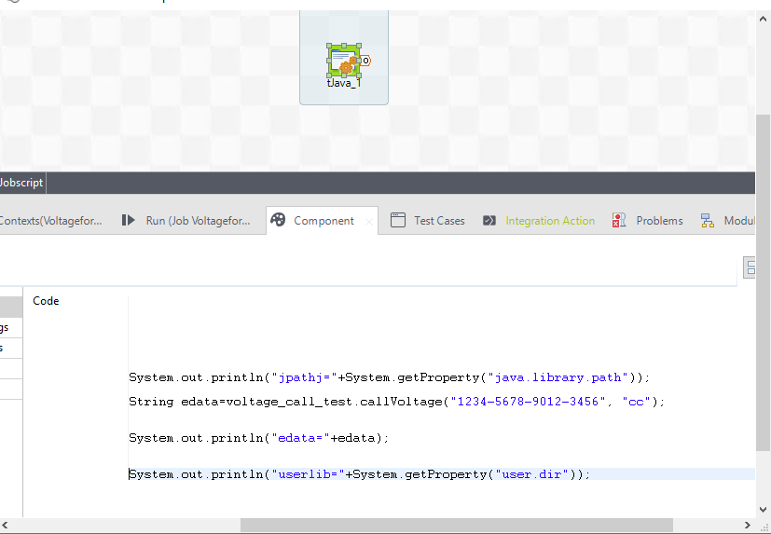

Run Window:
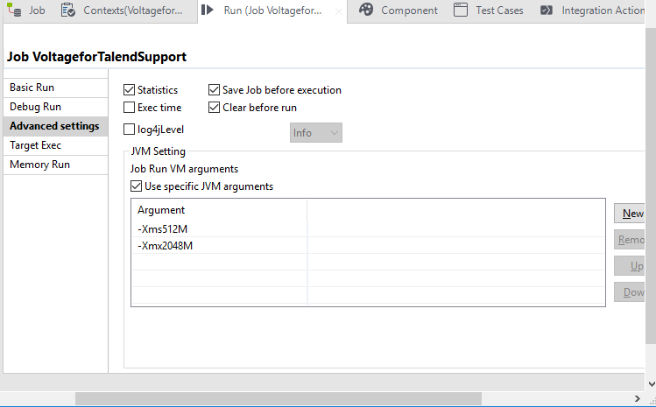
Routine:
Name: voltage_call

package routines;
import java.io.IOException;

import javax.xml.parsers.ParserConfigurationException;

import org.xml.sax.SAXException;

import com.voltage.securedata.enterprise.FPE;
import com.voltage.securedata.enterprise.LibraryContext;
import com.voltage.securedata.enterprise.VeException;
/*
* user specification: the function's comment should contain keys as follows: 1. write about the function's comment.but
* it must be before the "{talendTypes}" key.
*
* 2. {talendTypes} 's value must be talend Type, it is required . its value should be one of: String, char | Character,
* long | Long, int | Integer, boolean | Boolean, byte | Byte, Date, double | Double, float | Float, Object, short |
* Short
*
* 3. {Category} define a category for the Function. it is required. its value is user-defined .
*
* 4. {param} 's format is: {param} <type>[(<default value or closed list values>)] <name>[ : <comment>]
*
* <type> 's value should be one of: string, int, list, double, object, boolean, long, char, date. <name>'s value is the
* Function's parameter name. the {param} is optional. so if you the Function without the parameters. the {param} don't
* added. you can have many parameters for the Function.
*
* 5. {example} gives a example for the Function. it is optional.
*/
public class voltage_call_test {

/**
* helloExample: not return value, only print "hello" + message.
*
*
* {talendTypes} String
*
* {Category} User Defined
*
* {param} string("world") input: The string need to be printed.
*
* {example} helloExemple("world") # hello world !.
*/

public static String voltageCall(String columnData,String format){
String cipherText=null;
//try {
//voltage_call vc=new voltage_call();
cipherText = callVoltage(columnData,format);//applyVoltage(columnData,delimiter);
/*} catch (ParserConfigurationException e) {
e.printStackTrace();
} catch (SAXException e) {
e.printStackTrace();
} catch (IOException e) {
e.printStackTrace();
}*/
//return cipherText.substring(0,cipherText.length()-1);
return cipherText;
}
/* public static String applyVoltage(String columnData, String delimiter) throws ParserConfigurationException, SAXException, IOException {
//String[] individualTken = columnData.split("\\"+delimiter);
return callVoltage(individualTken[0],individualTken[1]);
}*/

public static String callVoltage(String plaintext,String format){

System.loadLibrary("vibesimplejava");

String policyURL = "xyz";
String identity = "*";
String sharedSecret = "abc";
//String format = "SSN";
String trustStorePath = "***";
String cachePath = "***";
String ciphertext = null;

LibraryContext library = null;
FPE fpe = null;

try {
// Setting client identifier fields, as shown below, is considered best practice.
// Dev Guide Code Snippet: LIBCTXBUILD; LC:8
// Create the context for crypto operations
library = new LibraryContext.Builder()
.setPolicyURL(policyURL)
.setFileCachePath(cachePath)
.setTrustStorePath(trustStorePath)
.setClientIdProduct("Simple_API_Java_FPE_Sample",
"1.2")
.build();

// Dev Guide Code Snippet: FPEBUILD; LC:5
// Protect and access the credit card number
fpe = library.getFPEBuilder(format)
.setSharedSecret(sharedSecret)
.setIdentity(identity)
.build();

//String plaintext = "994-00-9904";

// Dev Guide Code Snippet: FPEPROTECT; LC:1

//orignalVal = fpe.access(plaintext);
ciphertext = fpe.protect(plaintext);

} catch (Exception ex) {
System.out.println("Failed: " + ex.getMessage());
}
finally {

// Dev Guide Code Snippet: FPEDELETE; LC:4
// Explicit delete, required for JNI
if (fpe != null) {
fpe.delete();
}
// Dev Guide Code Snippet: LIBCTXDELETE; LC:4
// Explicit delete, required for JNI
if (library != null) {
library.delete();
}
}
return ciphertext;
// System.exit(exitStatus);

}
}
Error:


