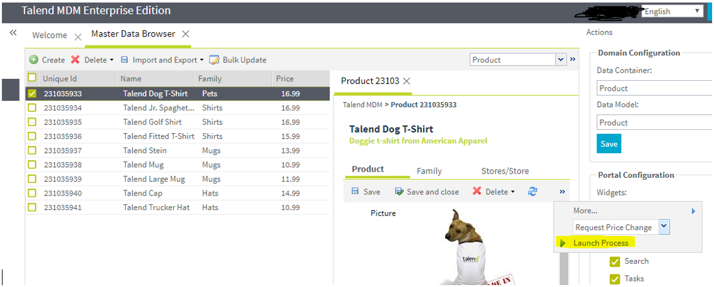

Created a task after launching the above process
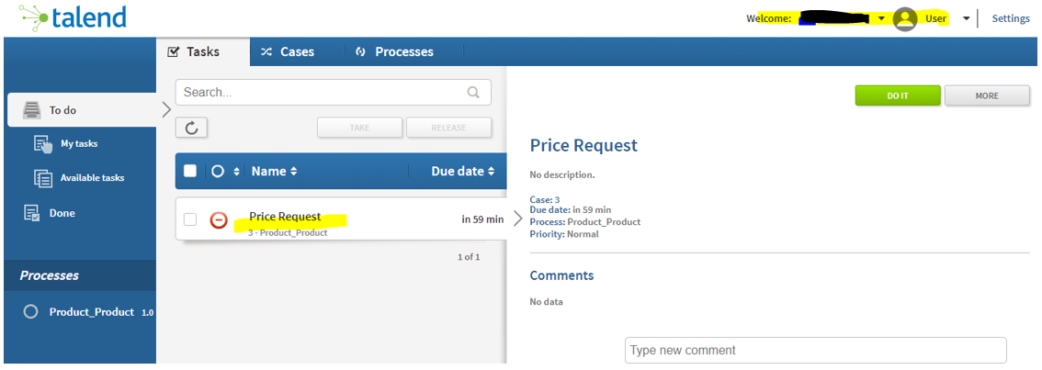

Added the new price –
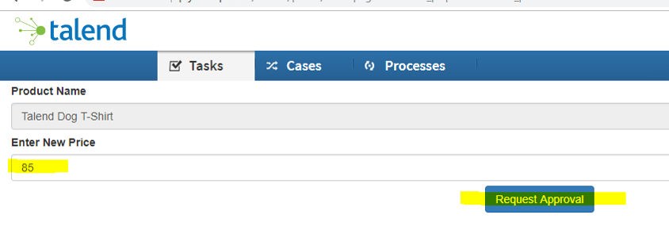
Logged in as the approver on mdm web uri
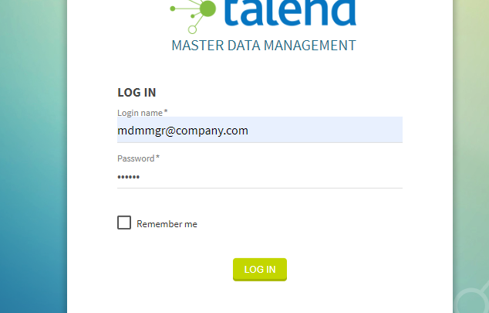
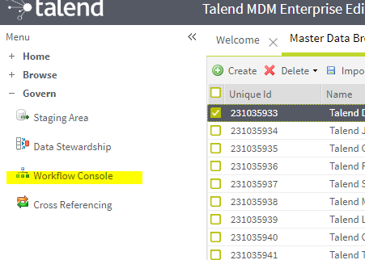
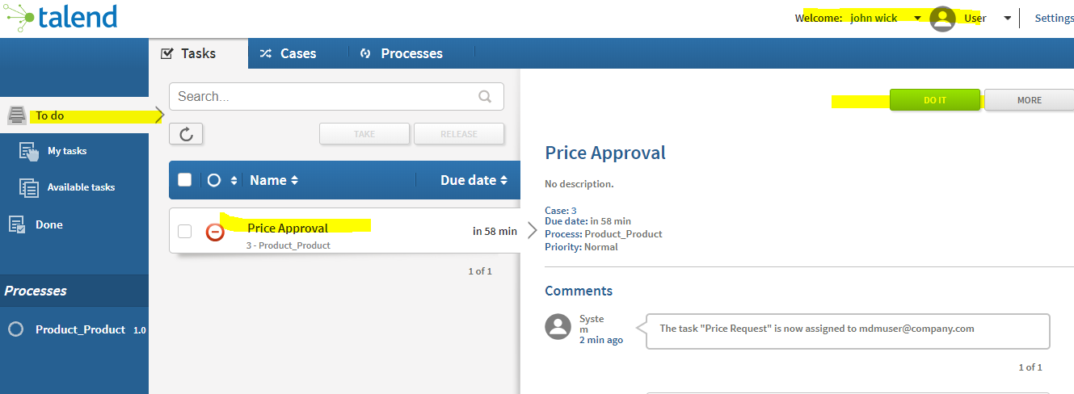

Approved price –
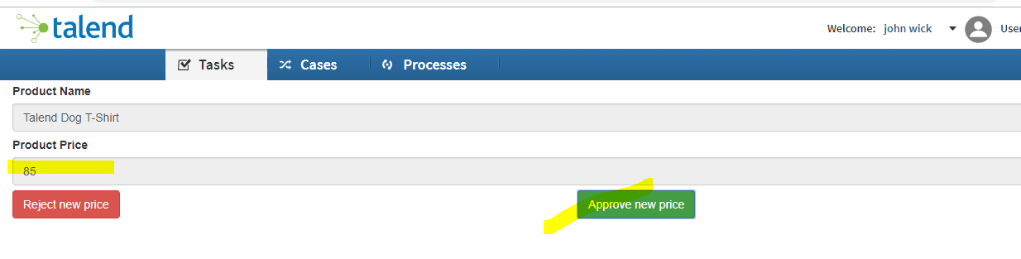

Price did not change –
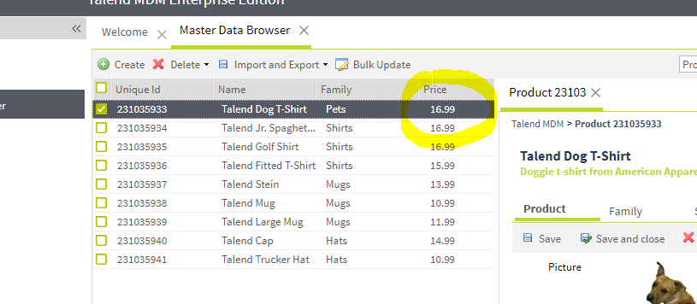

MDMContextConnector (already created with the demo)
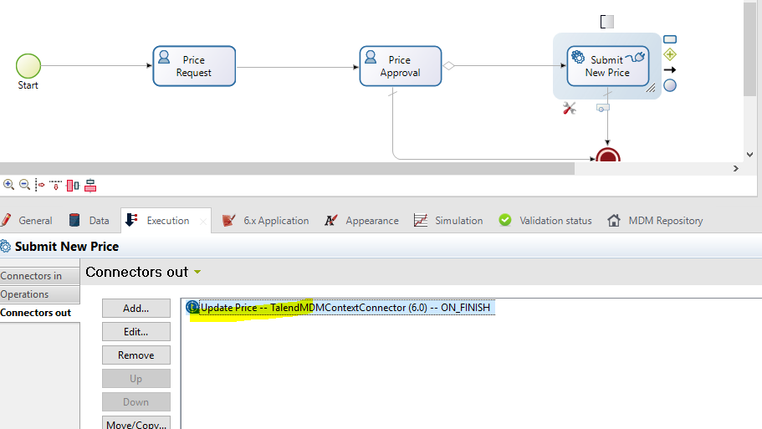

Does not have the URL.
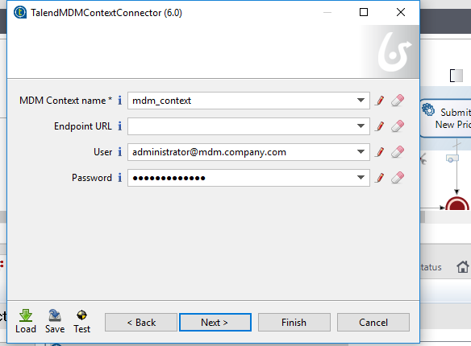
Tried a URL as given in the help document and tested with Adminstrative User. Got this error –
java.lang.reflect.InvocationTargetException
org.bonitasoft.engine.bpm.process.ProcessDefinitionNotFoundException: USERNAME=install | org.bonitasoft.engine.core.process.definition.exception.SProcessDefinitionNotFoundException: PROCESS_DEFINITION_ID=8567569434822336004 | Unable to find the process definition deployment info.
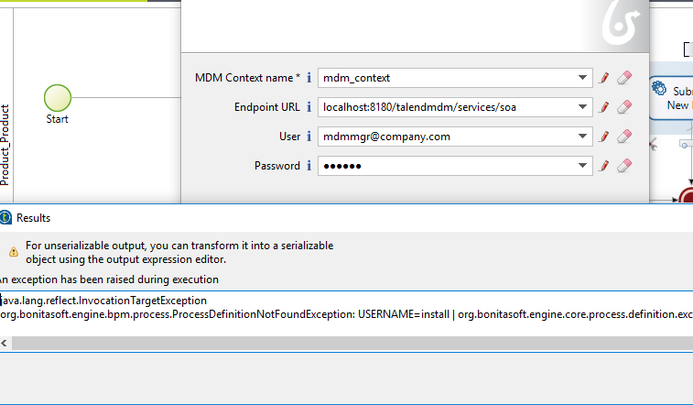
Here are the users that I have created –
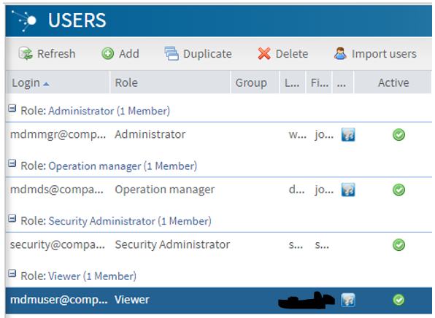

Tried with administrator as well –


