Job design:
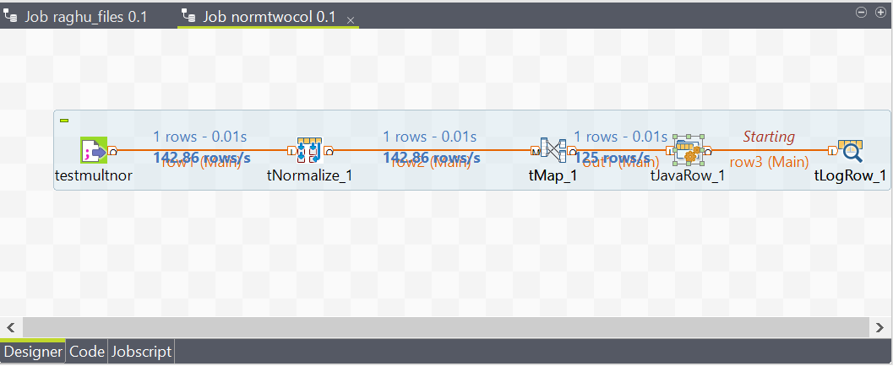

Tmap settings:
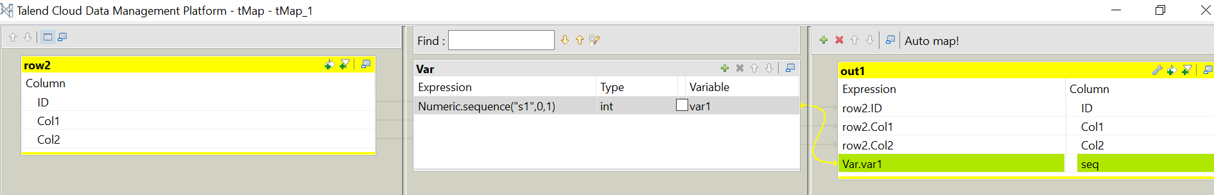

Tjavarow code as below:


