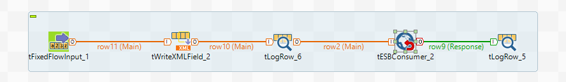
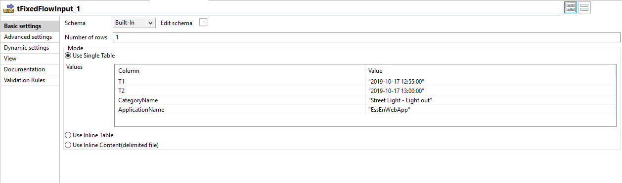

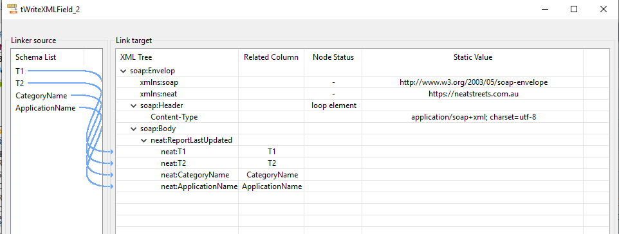

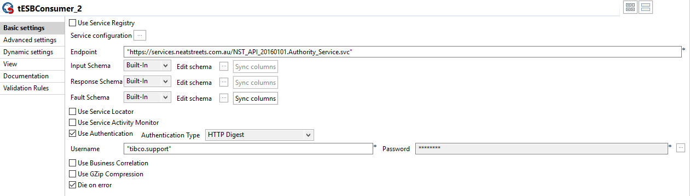

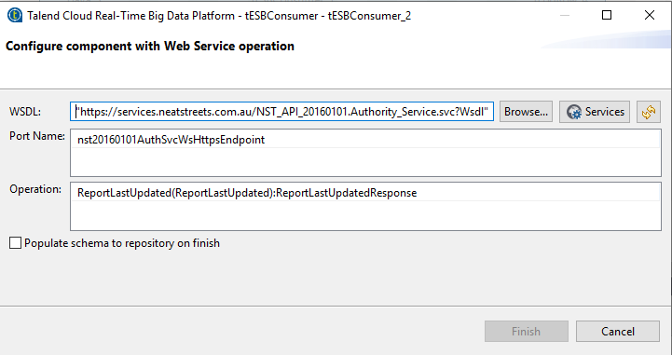

Starting job SOAPCALL at 11:26 20/12/2019.

[statistics] connecting to socket on port 3365
[statistics] connected
<?xml version="1.0" encoding="UTF-8"?>
<soap:Envelop xmlns:soap="http://www.w3.org/2003/05/soap-envelope" xmlns:neat="https://neatstreets.com.au">
<soap:Header>
<Content-Type>application/soap+xml; charset=utf-8</Content-Type>
</soap:Header>
<soap:Body>
<neat:ReportLastUpdated>
<neat:T1>2019-10-17 12:55:00</neat:T1>
<neat:T2>2019-10-17 13:00:00</neat:T2>
<neat:CategoryName>Street Light - Light out</neat:CategoryName>
<neat:ApplicationName>EssEnWebApp</neat:ApplicationName>
</neat:ReportLastUpdated>
</soap:Body>
</soap:Envelop>
[WARN ]: org.apache.cxf.wsdl.service.factory.ReflectionServiceFactoryBean - No method was found for the WSDL operation {https://neatstreets.com.au}Report.
[WARN ]: org.apache.cxf.wsdl.service.factory.ReflectionServiceFactoryBean - No method was found for the WSDL operation {https://neatstreets.com.au}SystemTimeNow.
[WARN ]: org.apache.cxf.wsdl.service.factory.ReflectionServiceFactoryBean - No method was found for the WSDL operation {https://neatstreets.com.au}ReportImageGetByUrl.
[WARN ]: org.apache.cxf.wsdl.service.factory.ReflectionServiceFactoryBean - No method was found for the WSDL operation {https://neatstreets.com.au}ReportCommentAdd.
[WARN ]: org.apache.cxf.wsdl.service.factory.ReflectionServiceFactoryBean - No method was found for the WSDL operation {https://neatstreets.com.au}ReportStatusUpdate.
[WARN ]: org.apache.cxf.phase.PhaseInterceptorChain - Interceptor for {https://neatstreets.com.au}Authority_Service#{https://neatstreets.com.au}ReportLastUpdated has thrown exception, unwinding now
java.lang.NullPointerException
at org.apache.cxf.ws.security.policy.interceptors.SecureConversationTokenInterceptorProvider.setupClient(SecureConversationTokenInterceptorProvider.java:102)
at org.apache.cxf.ws.security.policy.interceptors.SecureConversationOutInterceptor.issueToken(SecureConversationOutInterceptor.java:190)
at org.apache.cxf.ws.security.policy.interceptors.SecureConversationOutInterceptor.handleMessage(SecureConversationOutInterceptor.java:81)
at org.apache.cxf.ws.security.policy.interceptors.SecureConversationOutInterceptor.handleMessage(SecureConversationOutInterceptor.java:50)
at org.apache.cxf.phase.PhaseInterceptorChain.doIntercept(PhaseInterceptorChain.java:308)
at org.apache.cxf.endpoint.ClientImpl.doInvoke(ClientImpl.java:531)
at org.apache.cxf.endpoint.ClientImpl.invoke(ClientImpl.java:440)
at org.apache.cxf.endpoint.ClientImpl.invoke(ClientImpl.java:355)
at org.apache.cxf.endpoint.ClientImpl.invoke(ClientImpl.java:313)
at org.apache.cxf.endpoint.ClientImpl.invoke(ClientImpl.java:333)
at neatstreet.soapcall_0_1.SOAPCALL$GenericConsumer.invoke(SOAPCALL.java:683)
at neatstreet.soapcall_0_1.SOAPCALL.tWriteXMLField_2_InProcess(SOAPCALL.java:2600)
at neatstreet.soapcall_0_1.SOAPCALL$1ThreadXMLField_tWriteXMLField_2_Out.run(SOAPCALL.java:1249)
[FATAL]: neatstreet.soapcall_0_1.SOAPCALL - tESBConsumer_2 null
org.apache.cxf.interceptor.Fault
at neatstreet.soapcall_0_1.SOAPCALL$GenericConsumer.invoke(SOAPCALL.java:698)
at neatstreet.soapcall_0_1.SOAPCALL.tWriteXMLField_2_InProcess(SOAPCALL.java:2600)
at neatstreet.soapcall_0_1.SOAPCALL$1ThreadXMLField_tWriteXMLField_2_Out.run(SOAPCALL.java:1249)
Caused by: java.lang.NullPointerException
at org.apache.cxf.ws.security.policy.interceptors.SecureConversationTokenInterceptorProvider.setupClient(SecureConversationTokenInterceptorProvider.java:102)
at org.apache.cxf.ws.security.policy.interceptors.SecureConversationOutInterceptor.issueToken(SecureConversationOutInterceptor.java:190)
at org.apache.cxf.ws.security.policy.interceptors.SecureConversationOutInterceptor.handleMessage(SecureConversationOutInterceptor.java:81)
at org.apache.cxf.ws.security.policy.interceptors.SecureConversationOutInterceptor.handleMessage(SecureConversationOutInterceptor.java:50)
at org.apache.cxf.phase.PhaseInterceptorChain.doIntercept(PhaseInterceptorChain.java:308)
at org.apache.cxf.endpoint.ClientImpl.doInvoke(ClientImpl.java:531)
at org.apache.cxf.endpoint.ClientImpl.invoke(ClientImpl.java:440)
at org.apache.cxf.endpoint.ClientImpl.invoke(ClientImpl.java:355)
at org.apache.cxf.endpoint.ClientImpl.invoke(ClientImpl.java:313)
at org.apache.cxf.endpoint.ClientImpl.invoke(ClientImpl.java:333)
at neatstreet.soapcall_0_1.SOAPCALL$GenericConsumer.invoke(SOAPCALL.java:683)
... 2 more
[FATAL]: neatstreet.soapcall_0_1.SOAPCALL - tESBConsumer_2 null
org.apache.cxf.interceptor.Fault
at neatstreet.soapcall_0_1.SOAPCALL$GenericConsumer.invoke(SOAPCALL.java:698)
at neatstreet.soapcall_0_1.SOAPCALL.tWriteXMLField_2_InProcess(SOAPCALL.java:2600)
at neatstreet.soapcall_0_1.SOAPCALL$1ThreadXMLField_tWriteXMLField_2_Out.run(SOAPCALL.java:1249)
Caused by: java.lang.NullPointerException
at org.apache.cxf.ws.security.policy.interceptors.SecureConversationTokenInterceptorProvider.setupClient(SecureConversationTokenInterceptorProvider.java:102)
at org.apache.cxf.ws.security.policy.interceptors.SecureConversationOutInterceptor.issueToken(SecureConversationOutInterceptor.java:190)
at org.apache.cxf.ws.security.policy.interceptors.SecureConversationOutInterceptor.handleMessage(SecureConversationOutInterceptor.java:81)
at org.apache.cxf.ws.security.policy.interceptors.SecureConversationOutInterceptor.handleMessage(SecureConversationOutInterceptor.java:50)
at org.apache.cxf.phase.PhaseInterceptorChain.doIntercept(PhaseInterceptorChain.java:308)
at org.apache.cxf.endpoint.ClientImpl.doInvoke(ClientImpl.java:531)
at org.apache.cxf.endpoint.ClientImpl.invoke(ClientImpl.java:440)
at org.apache.cxf.endpoint.ClientImpl.invoke(ClientImpl.java:355)
at org.apache.cxf.endpoint.ClientImpl.invoke(ClientImpl.java:313)
at org.apache.cxf.endpoint.ClientImpl.invoke(ClientImpl.java:333)
at neatstreet.soapcall_0_1.SOAPCALL$GenericConsumer.invoke(SOAPCALL.java:683)
... 2 more
Exception in component tESBConsumer_2 (SOAPCALL)
org.apache.cxf.interceptor.Fault
at neatstreet.soapcall_0_1.SOAPCALL$GenericConsumer.invoke(SOAPCALL.java:698)
at neatstreet.soapcall_0_1.SOAPCALL.tWriteXMLField_2_InProcess(SOAPCALL.java:2600)
at neatstreet.soapcall_0_1.SOAPCALL$1ThreadXMLField_tWriteXMLField_2_Out.run(SOAPCALL.java:1249)
Caused by: java.lang.NullPointerException
at org.apache.cxf.ws.security.policy.interceptors.SecureConversationTokenInterceptorProvider.setupClient(SecureConversationTokenInterceptorProvider.java:102)
at org.apache.cxf.ws.security.policy.interceptors.SecureConversationOutInterceptor.issueToken(SecureConversationOutInterceptor.java:190)
at org.apache.cxf.ws.security.policy.interceptors.SecureConversationOutInterceptor.handleMessage(SecureConversationOutInterceptor.java:81)
at org.apache.cxf.ws.security.policy.interceptors.SecureConversationOutInterceptor.handleMessage(SecureConversationOutInterceptor.java:50)
at org.apache.cxf.phase.PhaseInterceptorChain.doIntercept(PhaseInterceptorChain.java:308)
at org.apache.cxf.endpoint.ClientImpl.doInvoke(ClientImpl.java:531)
at org.apache.cxf.endpoint.ClientImpl.invoke(ClientImpl.java:440)
at org.apache.cxf.endpoint.ClientImpl.invoke(ClientImpl.java:355)
at org.apache.cxf.endpoint.ClientImpl.invoke(ClientImpl.java:313)
at org.apache.cxf.endpoint.ClientImpl.invoke(ClientImpl.java:333)
at neatstreet.soapcall_0_1.SOAPCALL$GenericConsumer.invoke(SOAPCALL.java:683)
... 2 more
[statistics] disconnected

Job SOAPCALL ended at 11:27 20/12/2019. [exit code=1]

