- Then I tried this way – loop query on 1st array and I don’t get any values from the child loops. 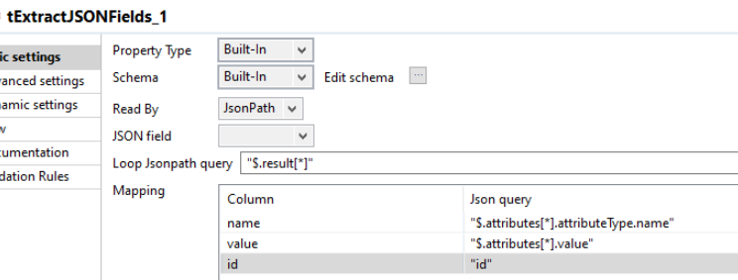

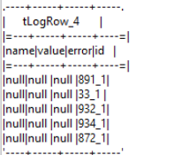

- Then I tried this way – loop on 1st array, but then I get data combined for the child loop.


